

VISVESVARAYA TECHNOLOGICAL UNIVERSITY
“Jnana Sangama”, Belgaum– 590 014

AProject Report On
“AI-POWERED HEALTHCARE PLATFORM FOR EARLY
DISEASE DETECTION”
Submitted in partial fulfillment of the requirements for the award of the degree of
BACHELOR OF ENGINEERING

in
INFORMATION SCIENCE AND ENGINEERING
Submitted by
BINDU H L 1KI22IS006
KUSHI P 1KI22IS022
SPOORTHI K S 1KI22IS056
TEJASWINI R N 1KI22IS058

Under the Guidance of
Prof. Divya C Kumar B.E, M.Tech Assistant Professor, Dept. of ISE KIT, Tiptur

DEPARTMENT OF INFORMATION SCIENCE AND ENGINEERING
Kalpataru Institute of Technology, Tiptur – 572 201
2025-2026


Kalpataru Institute of Technology, Tiptur – 572 201
DEPARTMENT OF INFORMATION SCIENCE AND ENGINEERING

CERTIFICATE
This is to certify that the project work entitled “AI-POWERED HEALTHCARE PLATFORM FOR EARLY DISEASE DETECTION” has been successfully carried out by BINDU H L (1KI22IS006), KUSHI P (1KI22IS022), SPOORTHI K S (1KI22IS056) and TEJASWINI R
N (1KI22IS058) in partial fulfillment for the award of the degree of Bachelor of Engineering in Information Science and Engineering of the Visvesvaraya Technological University, Belgaum during the academic year 2025-2026. It is certified that all corrections and suggestions indicated for internal assessment have been incorporated in the report. The project report has been approved as it satisfies the academic requirements with respect to the project work prescribed for the Bachelor of Engineering degree in Information Science and Engineering.

Guide HOD

Prof. Divya C Kumar BE, M.Tech Dr. Rajashekar K J M.Tech, Ph.D
Assistant Professor Professor & Head
Dept. of ISE, KIT Dept.of ISE, KIT

Principal

Dr. Sateesh Kumar H C M.Tech, Ph.D
Principal, KIT

EXTERNAL VIVA VOCE

Name of the Examiners Signature with Date

ACKNOWLEDGEMENT

The satisfaction and great happiness that accompany the successful completion of any task would be incomplete without mentioning about the people who made it possible. Here we make an honest attempt to express our deepest gratitude to all those who have been helpful and responsible for the successful completion of our project.

We would like to extend our heartfelt thanks to Dr. Sateesh Kumar H C, Principal, Kalpataru Institute of Technology, Tiptur for his continuous support and encouragement through the course of this project.

We also express our sincere gratitude to Dr. Rajashekar K J, Professor and Head of Department, Department of Information Science and Engineering, Kalpataru Institute of Technology, Tiptur for his continuous guidance, valuable suggestion and encouragement during course of our project.

We are deeply indebted to our internal guide, Prof. Divya C Kumar, Assistant Professor, Department of Information Science and Engineering, Kalpataru Institute of Technology, Tiptur for her constant support, technical assistance and constructive suggestions and guidance for successful completion of our project. We are especially thankful to her for the motivation and enthusiasm that inspired us to complete our work successfully.

We would like to thank all faculty members of Department of Information Science and Engineering, KIT, Tiptur, our family members, and our friends who have directly or indirectly contributed to our project.

Thanking You BINDU H L 1KI22IS006
KUSHI P 1KI22IS022 SPOORTHI K S 1KI22IS056 TEJASWINI R N 1KI22IS058

ABSTRACT

Machine Learning (ML) and Artificial Intelligence (AI) are transforming modern healthcare. This project, titled AI-Powered Healthcare Platform for Early Disease Detection uses ML algorithms like Random Forest and SVM to accurately predict multiple diseases including Diabetes, Heart Disease, and Parkinson’s Disease. Built using the Streamlit library and deployed on Streamlit Cloud, the system provides an interactive interface for instant predictions based on user inputs. It also integrates doctor appointment booking, medicine reminders, health education videos, and ambulance services into a single platform. With secure data handling, real-time processing, and a scalable modular design, the system enables efficient, reliable, and accessible digital healthcare management. In addition, the system focuses on enhancing patient engagement and preventive healthcare by promoting timely medical consultation and continuous health monitoring. Its user-friendly design ensures ease of use for people of all age groups, while automated features reduce manual effort for both patients and healthcare providers. By combining intelligent disease prediction with essential healthcare services, the platform supports early diagnosis, improves treatment planning, and helps reduce emergency risks, ultimately contributing to improved patient outcomes and a more efficient healthcare ecosystem.
Keywords: Machine Learning, Artificial Intelligence, Random Forest Classifier, Support Vector Machine (SVM), Streamlit, Diabetes, Heart Disease, Parkinson’s Disease, Doctor Appointment, Medicine Reminder, Health Videos, Ambulance Booking, Disease Prediction

CONTENTS

TITLE | PAGE NO
CONTENTS | i-ii
LIST OF TABLES | iii
LIST OF FIGURES | iv
CHAPTERS
1 INTRODUCTION | 1
1.1 Background | 2
1.2 Existing System | 2
1.2.1 The Drawbacks | 3
1.3 Proposed System | 3
1.4 Advantages of Proposed System | 4
2 LITERATURE REVIEW | 6
3 SYSTEM REQUIREMENT SPECIFICATION | 9
3.1 Software Requirements Specification | 9
3.2 Hardware Requirements Specification | 9
3.3 Functional Requirements | 10
3.4 Non-Functional Requirements | 10
3.5 Data Requirements | 10
4 SYSTEM ANALYSIS | 12
4.1 Problem Identification | 12
4.1.1 Challenges | 13
4.2 Objectives | 13
4.3 Methodology | 15
5 SYSTEM DESIGN | 16
5.1 Architectural Design | 16
5.2 Detailed Design | 17
5.3 Output Design | 17

  - Input Design 18
  - Class Diagram 18
  - Sequence Diagram 19
  - Activity Diagram 20
  - Data Flow 21
- IMPLEMENTATION 23
  - Algorithm 24
    - Random Forest Algorithm 24
    - Support Vector Machine Algorithm 24
- MODULE SPLIT UP 26
  - Dataset Collection 26
  - Data Analysis and Pre-Processing 27
  - Feature Engineering 28
  - Splitting the Dataset 28
  - Training Model 28
  - Evaluating and Testing 30
- TESTING 31
  - Unit Testing 31
  - Integration Testing 31
  - System Testing 31
  - Functional Testing 32
  - Alpha Testing 32
  - Beta Testing 32
  - Unit Testing Case 32
- RESULTS AND DISCUSSIONS 34
- CONCLUSION AND FUTURE WORK 39
REFERENCES 40
BIBLIOGRAPHY 41
ANNEXURE 42

FIGURE NO | TITLE | PAGE NO
4.1 | Overview of Early Disease Detection System | 15
5.1 | Detailed Design of Early Disease Detection System | 17
5.2 | Class Diagram of System | 19
5.3 | Sequence Diagram of Disease Detection | 20
5.4 | Activity Diagram of Disease Detection | 21
5.5 | Data flow Diagram Level 0 for Disease Detection System | 22
5.6 | Data flow Diagram Level 1 for Disease Detection System | 22
7.1 | Dataset Collection for Diabetes Disease Detection | 26
7.2 | Dataset Collection for Parkinsons Disease Detection | 26
7.3 | Dataset Collection for Heart Disease Detection | 27
7.4 | Model-Selected for Diabetes Disease Detection | 29
7.5 | Model-Selected for Heart Disease Detection | 29
7.6 | Model-Selected for Parkinsons Disease Detection | 29
9.1 | Diabetes Disease Prediction | 35
9.2 | Heart Disease Prediction | 35
9.3 | Parkinson’s Disease Prediction | 36
9.4 | Doctor Appointment Booking | 36
9.5 | Medicine Reminder System | 37
9.6 | Doctor Appointment Booking | 37
9.7 | Parkinson’s Disease Awareness Videos | 38
9.8 | Heart Disease Awareness Videos | 38

TABLE NO. | TITLE | PAGE NO
8.1 | Sample Test Cases | 33
9.1 | Accuracy Level for all three Disease | 34

Chapter 1

INTRODUCTION

The world is currently experiencing a rapid technological transformation, where the demand for intelligence and accuracy is continuously increasing. In today’s digital era, people are highly dependent on the internet; however, they often neglect their physical health. Minor health issues are frequently ignored, and individuals avoid visiting hospitals, which may later develop into serious diseases.
Taking advantage of advancements in technology, the primary aim of this project is to develop a system capable of predicting diseases at an early stage based on symptoms provided by patients, without requiring them to visit hospitals or physicians. Machine Learning (ML), a subset of Artificial Intelligence (AI), focuses on developing algorithms that improve automatically through experience and data usage. Machine Learning consists of two main phases: training and testing. It provides an efficient and effective platform in the medical field to address various healthcare challenges at a much faster rate.
Machine Learning can be broadly categorized into two types: Supervised Learning and Unsupervised Learning. In supervised learning, models are trained using labeled datasets, whereas unsupervised learning models discover patterns from unlabeled data. The objective of this work is to identify a reliable and accurate Machine Learning algorithm for disease prediction. This project utilizes supervised learning techniques to predict diseases effectively.
The core feature of this system is the use of Machine Learning algorithms to enable accurate early disease prediction and enhance patient care. Timely medical intervention plays a crucial role in saving lives; however, delays in diagnosis often lead to fatal outcomes. Healthcare industries frequently face challenges in prioritizing patients due to time constraints, despite generating large volumes of patient health data. Extracting meaningful insights from this data can significantly improve decision-making and treatment prioritization.
This project integrates three Machine Learning models designed to predict heart disease, Parkinson’s disease, and diabetes at an early stage. Patients identified as high-risk can receive timely treatment, enabling hospitals to reduce delays and improve clinical decision-making efficiency.
Three separate datasets corresponding to the diseases were collected from Kaggle. After data collection, thorough analysis and visualization were performed for better understanding. Data preprocessing included handling missing values, encoding categorical variables.
Initially, the problem statement was clearly defined to determine the required data methods.
The dataset was then divided into training and testing sets, with 80% of the data used for training

and 20% for testing. Several classification algorithms—Logistic Regression, Random Forest Classifier, Support Vector Machine (SVM), and Boost—were applied to all three datasets. Among these, the Random Forest Classifier consistently demonstrated superior performance across all datasets. It achieved testing accuracies of 98.52% for heart disease, 98.73% for kidney disease, and 80.55% for diabetes.
The trained models were serialized using Python’s Pickle library and deployed through a web application developed using the Flask framework, ensuring easy user interaction. Additionally, visualization dashboards for all three datasets were created using Tableau to enhance data interpretation and insights.

Background
With the increasing availability of patient health data in the medical industry, machine learning techniques offer a significant opportunity to improve disease detection and diagnosis. This project presents a comprehensive prediction system capable of identifying multiple diseases simultaneously, overcoming the limitations of existing systems that focus on single-disease prediction and often deliver lower accuracy. Traditional systems are largely rule-based and manually programmed, restricting their scalability and adaptability.
By integrating multiple machine learning models into a unified framework, the proposed system enhances diagnostic efficiency and reduces dependency on manual medical assessments. The system leverages historical patient data to learn complex patterns and relationships between symptoms and diseases, enabling accurate predictions even in early stages. Unlike conventional systems, this approach supports data-driven decision-making, improves scalability, and can be continuously updated as new data becomes available, thereby ensuring adaptability to evolving healthcare needs and improving overall patient outcomes.

Existing System and Their Drawbacks
Although existing systems can predict certain diseases, they fail to identify disease subtypes or account for multiple health conditions arising from a single disease. These systems typically handle only structured data and produce broad, ambiguous predictions. Numerous disease prediction models have been developed over time using various machine learning algorithms, providing reasonable accuracy. However, several limitations persist. Firstly, existing systems are expensive and accessible only to financially privileged individuals. Secondly, these prediction systems are often non-specific, limiting their effectiveness in real-world healthcare applications.

indefinite so far. In current past, countless disease estimates classifications have been advanced and in procedure. So that, a machine can envisage a positive disease but cannot expect the sub types of the diseases and diseases caused by the existence of one bug. For occurrence, if a group of people are foreseen with Diabetes, doubtless some of them might have complex risk for Heart viruses due to the actuality of Diabetes. The remaining schemes fail to foretell all possible surroundings of the tolerant.

The Drawbacks
Does not analyze the disease: This drawback means that the system or technology in question does not perform detailed analysis or diagnosis of diseases or health conditions. For example, if you're talking about a health-related tool or software, not analyzing the disease implies that it doesn't provide specific insights into the nature or characteristics of a medical condition.
Less security: This suggests that the system or technology has weaker security measures in place compared to other solutions. It could mean that it's more vulnerable to cyber threats like hacking, data breaches, or unauthorized access. Security is crucial, especially for systems handling sensitive information or transactions.
There is no feedback system: This indicates that the system lacks a mechanism for users to provide feedback or interactively engage with it. A feedback system is important for users to share their experiences, report issues, or suggest improvements. Without this, it can be challenging to gather user input for refining or enhancing the system.

Proposed System
The proposed system of AI powered healthcare system for early disease is designed to analyze patient health parameters and symptoms using intelligent algorithms and predictive models. In this system, we utilize various machine learning algorithms and data processing tools to predict the likelihood of diseases based on user-provided inputs. The symptoms and clinical parameters entered by the patient are compared with a previously available dataset that has been preprocessed, trained, and validated to ensure accuracy. To the best of our knowledge, in the area of medical big- data analytics, none of the existing work has focused on efficiently integrating both structured datasets and comparing with the patient’s disease we will predict the accurate percentage disease of the patient. Furthermore, the platform enhances reliability by using cross-validation, standardized evaluation metrics, and optimized algorithms, ensuring that predictions are both interpretable and clinically meaningful. Furthermore, the platform is designed with a user-friendly interface that enables seamless input of patient data, real-time processing, and clear visualization of predicted outcomes. This empowers patients to actively participate in their healthcare management while providing clinicians with actionable insights that complement traditional diagnostic methods.

The system is designed to predict probable diseases by analysin g medical datasets, including Heart Disease, Diabetic Disease, and Parkinson’s Disease. Unlike existing systems that focus on limited data types or single-disease prediction, this project integrates multiple healthcare management services into one comprehensive platform.
The proposed system extends beyond disease prediction by incorporating essential healthcare functionalities such as:
Doctor Appointment Booking: Enables users to schedule consultations with medical professionals directly through the application.
Medicine Reminder: Sends timely notifications and email alerts to ensure patients take their prescribed medications correctly.
Health Maintenance Videos: Provides educational video content on healthy living, preventive care, and fitness routines for overall well-being.
Ambulance Booking Service: Allows users to request immediate ambulance support in emergency situations, ensuring rapid medical response.

Advantages of Proposed System
Comprehensive Health Monitoring: AI powered healthcare platform for early disease detection system can continuously monitor various health parameters and symptoms. By analyzing a broader range of data, it can detect potential patterns or early signs of different diseases, enabling proactive intervention and treatment.
Early Detection and Prevention: This system can facilitate early detection of diseases based on predictive analytics and machine learning algorithms. Early detection often leads to more effective treatment outcomes and can prevent disease progression.
Personalized Recommendation: The system can provide personalized recommendations based on individual health data and predictive analysis. This can include lifestyle modifications, preventive measures, or timely medical interventions tailored to specific health risks.
Efficient Resource Allocation: By predicting diseases in advance, healthcare resources can be allocated more efficiently. This includes optimizing hospital resources, prioritizing patient care, and reducing unnecessary medical procedures.
Improved Patient Outcomes: With early detection and personalized interventions, patient outcomes can improve significantly.
Data-Driven Insights: The system generates valuable insights from large datasets, which can contribute to medical research, public health initiatives, and policy decisions aimed at disease prevention and management. These insights help identify emerging health trends, risk factors, and patterns that may not be visible through manual analysis.

Enhanced Healthcare Access: By leveraging technology for disease prediction, healthcare access can be expanded to underserved populations or remote areas where traditional healthcare services may be limited.
Continuous Improvement: Over time, the system can learn and adapt based on new data and feedback, enhancing its predictive accuracy and usability.
High Accuracy: Imagine you have a disease prediction system that uses advanced algorithms to analyze various health indicators like symptoms, medical history, and lifestyle factors. When we say the system has "high accuracy," it means that it's very good at correctly predicting whether someone has a particular disease or is at risk of developing it.
Easily analyze the disease: When we say a system can "easily analyze the disease," it means that it can quickly and effectively process information about a disease to identify its characteristics, causes, symptoms, and potential treatments. This could involve using advanced algorithms, medical databases, or expert knowledge to interpret data and provide meaningful insights.
Efficient Resource Utilization: Hospitals and clinics can use prediction insights to manage resources like doctors, diagnostic tools, and emergency facilities more efficiently, improving overall healthcare delivery.
Supports Multi-Disease Screening at Once: Unlike traditional systems that focus on a single disease, this model screens for multiple conditions such as diabetes, heart disease, and Parkinson’s simultaneously. This multi-disease capability saves time and provides a comprehensive health assessment in one session. It is especially useful for patients with overlapping symptoms that may indicate more than one disease. The integrated approach helps deliver clearer, broader insights and prevents misdiagnosis.
Enhances Research and Future Medical Advancements: The data accumulated through this system can play a crucial role in medical research, helping analysts identify emerging health trends or new disease patterns. Researchers can use these insights to develop new treatment strategies or refine existing medical protocols. Over time, the system becomes a valuable knowledge base that supports advancements in healthcare technologies. This contributes to a more innovative and data- driven future of medicine.
Data Privacy & Security: With proper encryption and secure data-handling protocols, the system ensures patient data confidentiality, meeting healthcare compliance standards. Beyond local healthcare applications, the aggregated data can support global health initiatives. By identifying patterns and trends across regions, the system can inform public health policies. Additionally, such large-scale data analysis helps detect early warning signals for potential outbreaks or rising disease burdens.

Chapter 2

LITERATURE REVIEW

Literature survey is mainly carried out in order to analyze the background of the current project which helps to find out flaws in the existing system & guides on which unsolved problems we can work out. So, the following topics not only illustrate the background of the project but also uncover the problems and flaws which motivated to propose solutions and work on this project. Some of the distinguished ones, which are relevant and carry basic information for this paper have been highlighted briefly. Following section explores different references that discuss about several topics related to hole detection and associated fastener identification.
Prashanth, Dr. Anu Rathee et. al., [1] The primary goal of this study was to develop a system that could accurately forecast several diseases. The user doesn't have to navigate via several websites thanks to this project, which also saves time. Early diagnosis of diseases can lengthen your life expectancy. we explored the application of machine learning techniques for the prediction of multiple diseases, with a specific focus on heart disease, diabetes, and Parkinson's disease. It achieved a high accuracy of 98.3%. It can assist healthcare providers in making informed decisions, enhance patient care, and improve resource allocation within healthcare systems. Earlier prediction was having the less accuracy because of lack of the information, but the same one was developed. Furthermore, it holds promise for population-level disease surveillance, enabling prompt detection of disease outbreaks and implementation of preventive measures. The literature survey conducted as part of this research project highlighted the growing body of knowledge on machine learning- based disease prediction, specifically focusing on the application of SVM models.
Indukuri Mohit, K. Santhosh Kumar, Avula Uday Kumar Reddy et. al., [2] The actions performed in this work are done by the laptop with an i5 processor and developed the code using python. The algorithms used in this work are Logistic Regression, KNN, SVM, and the accuracies are calculated using the cross-validation with factor cv as 10. The accuracies of each disease are illustrated through bar graphs. The datasets of diseases are divided into training and test datasets for classification. The proposed work brings diabetes, heart disease under a single platform by deploying the trained models using the flask API framework which is a lightweight framework. Three classification algorithms are used for training the models, in which the logistic regression gave good accuracy values for the disease prediction of diabetes and breast cancer and KNN for the disease prediction of heart disease. KNN's highest accuracy is calculated by picking the highest value. Overall, this work demonstrates a practical approach by combining multiple predictions. The integrated system provides users with an accessible interface to obtain quick and reliable

Divya Mandem, B. Pranja et. al., [3] The system analysis the symptoms provided by the user as input and gives the probability of the disease as an output Disease Prediction is done by implementing the random forest classifier and also, we implement Malaria and Pneumonia using Deep Learning Model and in the prosed method it gives the better accuracy and we design web allocation for prediction system. The aim of this project is to predict disease based on symptoms. The project is set up in such a way that the device takes the user’s symptoms as input and generates an output, which is disease prediction. A prediction accuracy probability of 95% is obtained on average. The grails system was used to successfully incorporate Disease Predictor. This approach not only improves prediction accuracy but also provides a scalable and user-friendly platform that can be expanded to include additional diseases in the future.
Mohammed Juned Shaikh, Soham Manjrekar, Danish Khan, Muzaffar Khan, Danish Jamadar et. al., [4] The medical industry generates a huge amount of patient data which can be processed in a lot of ways. So, with the help of machine learning, we have created a Prediction System that can detect more than one disease at a time. Many of the existing systems can predict only one disease at a time and that too with lower accuracy. In the system diabetes disease prediction model used KNN algorithm, heart disease uses the XG Boost algorithm and liver uses the random forest algorithm as these gave the best accuracy accordingly. There when the patient adds the parameter according to the disease it will show whether the patient has a disease or not according to the disease selected.
Rudra A. Godse, Smita S. Gunjal, Karan A. Jagtap, Neha S. Mahamuni, Prof. Suchita Wankhade et. al., [5] The traditional way of diagnosis is not sufficient for the treatment of serious disease. In this study we have developed a platform for the prediction of early diseases like heart, diabetes, Parkinson’s disease. By which patient can predict multiple diseases on single platform. This disease prediction system uses Machine Learning algorithm named as Support vector machine. This paper gives research of multiple researches done in this field. Our Proposed System aims at bridging gap between Doctors and Patients which will help both classes of users in achieving their goals. This system provides support for multiple disease prediction using different Machine Learning algorithms. The present approach of many systems focuses only on automating this process which lacks in building the user’s trust in the system. By providing Doctor’s recommendation in our system, we ensure user’s trust side by side ensuring that the Doctor’s will not feel that their Business is getting affected due to this System. The present approach of many systems focuses only on automating this process which lacks in building the user’s trust in the system. By providing Doctor’s recommendation in our system, we ensure user’s trust side by side ensuring that the Doctor’s will not feel that their Business is getting affected due to this System.

Abhishek Patter, Sameer Kur hade, Manoj Salunke et. al., [6] Predicting the disease earlier can improve the human health. The aim of this project is to predict multiple diseases based on symptoms. The project is built in such a way that the system takes the patients symptoms as input and generates an output, which is nothing but the disease prediction. This model can help to reduce the cost required in dealing with this disease and also help to improve the recovery process. Predicting the disease earlier can improve the human health. The aim of this project is to predict multiple diseases based on symptoms. The project is built in such a way that the system takes the patients symptoms as input and generates an output, which is nothing but the disease prediction. This model can help to reduce the cost required in dealing with this disease and also help to improve the recovery process. By using this system patient can reduce the money required for treatment and can save the time.
Ankush Singh, Ashish Yadav, Saloni Shah, Renuka Nagpure et. al., [7] A lot of analysis over existing systems in the health care industry considered only one disease at a time. For example, one system is used to analysis diabetes, another is used to analysis diabetes retinopathy, and another system is used to predict heart disease. Maximum systems focus on a particular disease. When an organization wants to analysis their patient’s, health reports then they have to deploy many models. The approach in the existing system is useful to analysis only particular diseases. In multiple diseases prediction system, a user can analyze more than one disease on a single website. The main objective of this project was to create a system that would predict more than one disease and do so with high accuracy. Because of this project the user doesn’t need to traverse different websites which saves time as well. Diseases if predicted early can increase your life expectancy as well as save you from financial troubles. Furthermore, the system underscores the importance of early detection: by identifying diseases at an early stage, patients can take timely preventive measures, which can increase life expectancy, reduce the severity of treatment required, and alleviate financial burdens. associated with advanced medical care.
Padmaja Pulicherla, Padala Raviteja, Peddi Akash, Veldhandi Sai Krishna et. al., [8] Data is a valuable resource in our digital age, and vast amounts of data were produced across all industries. All patient-related data is included in the healthcare sector's data. Here, a generic architecture for illness prediction in the healthcare sector has been put out. Several of the current models focus on just one illness for each analysis. One analysis, for example, might be performed for skin illnesses, cancer, and diabetes. There isn't a mechanism in place that can examine many diseases at once. As a result, we are focusing on providing users with rapid and precise illness predictions based on the symptoms they submit. So, we are suggesting a technique that may be used to forecast various illnesses. We will examine the diseases of diabetes, heart disease, Parkinson’s disease.

Chapter 3

SYSTEM REQUIREMENT SPECIFICATION
System Requirement Specification is a fundamental document, which forms the foundation of the software development process. It not only lists the requirements of a system but also has a description of its major feature. An SRS is basically an organization's understanding (in writing) of a customer or potential client's system requirements and dependencies at a particular point in time (usually) prior to any actual design or development work. It's a two-way insurance policy that assures that both the client and the organization understand the other's requirements from that perspective at a given point in time. The SRS also functions as a blueprint for completing a project with as little cost growth as possible in a better way. The SRS is often referred to as the "parent" document because all subsequent project management documents, such as design specifications, statements of work, software architecture specifications, testing and validation plans, and documentation plans are related to it. It not only lists the requirements of a system but also has a description of its major feature. System Requirement Specification plays important role in performance.

Software Requirement Specification
A Software Requirements Specification (SRS) is a document that clearly defines what the software will do and how it is expected to perform under various conditions. It outlines the functional and non-functional requirements needed to meet the expectations of all stakeholders, including end users, developers, and business managers. The latest version of the software becomes more compatible, efficient, and easier to handle when guided by a well-defined SRS. This document acts as a blueprint for the development team, ensuring that the software’s design, implementation, and testing phases follow a unified direction.

Hardware Requirement Specification
The performance mainly depends on the processor. The hardware requirements specification (HRS)The performance mainly depends on the processor. The hardware requirements specification (HRS) will follow a format such as:
Processor : Core i3/i5/i7

RAM : 2-4 GB

Hard Disk : 250 GB HDD or 128 GB SSD

Input device : Standard Keyboard and Mouse

Output device : High Resolution Monitor

Functional Requirement
Functional Requirement defines a function of a software system and how the system must behave when presented with specific inputs or conditions. These may include calculations, data manipulation and processing and other specific functionality. It includes collecting, setting up, keeping track and documentation of the data. In this system following are the functional requirements. To begin, the necessary tracking details are collected to ensure accurate monitoring throughout the process. Once the requirements are identified, the software is set up after performing a thorough check of both hardware and software compatibility. The system is then kept running continuously to enable effective tracking of activities or parameters. Finally, all the gathered data is carefully documented for further analysis and evaluation.

Non-Functional Requirements
Non-functional requirements are the requirements which are not directly concerned with the specific function delivered by the system. They specify the criteria that can be used to judge the operation of a system rather than specific behaviors. They may relate to emergent system properties such as reliability, response time and store occupancy.
Non-functional requirements arise through the user needs, because of budget constraints, organizational policies, and the need for interoperability with other software and hardware systems or because of external factors such as Non-functional requirements arise from user needs, budget limitations, organizational policies, and the necessity for interoperability with existing software and hardware systems, along with other external factors.
These include product requirements, organizational requirements, user requirements, and basic operational requirements. Together, they ensure the system meets quality standards such as performance, reliability, and compatibility. Both functional and non-functional requirements ultimately depend on the accuracy and efficiency expected during the system’s deployment.

Data Requirements
The system takes user-generated queries as inputs and produces corresponding outputs based on database interactions. Inputs typically include actions such as creating an account, creating a class, making a payment, or requesting specific details. The outputs are generated when the user asks the server for information such as account details, timestamps, added classes, Wishlist items, or transaction history. All inputs are processed through predefined logic to ensure accurate, reliable, and timely responses. The external interface requirement includes a well-designed Graphical User Interface (GUI) that supports both users and administrators. The software provides an intuitive and visually appealing interface that makes it easy to perform essential operations like creating,

updating, viewing, and managing class details. Users can conveniently select their city, browse class lists, and apply search or filter options to find the most suitable choices.
Additionally, the interface allows users to view class locations through Google Maps, manage their Wishlist by adding or removing items, and explore similar classes displayed on the detail page. Features such as "Ask a friend to join," creating classes, adding packages, scheduling shifts, and a dedicated login/register component for both new users and guests further enhance usability and functionality.
Following are the non-functional requirements of the application
Reliability: The system must consistently provide accurate predictions without frequent failures or errors. It should remain stable even during heavy user interactions to ensure dependable healthcare support.
Security: The application must protect all user data, especially sensitive medical information, through encryption, secure authentication, and compliance with data protection standards. Unauthorized access must be strictly prevented.
Scalability: The system must be capable of handling increased numbers of users, larger datasets, and additional diseases in the future without compromising performance.
Maintainability: The application should be easy to update, debug, and improve over time. Developers must be able to modify modules without affecting the entire system.
Availability: The application should be accessible with minimal downtime, ensuring that users can receive disease predictions and recommendations whenever needed.
Portability: The system should be able to operate smoothly on different devices and platforms such as Windows, Linux, mobile devices, and web browsers without requiring major modifications.
Accuracy: The system must ensure high precision in disease prediction by validating models regularly and updating datasets to maintain reliability.
Response Time: The system should deliver prediction results quickly, ensuring that users do not experience delays when submitting health parameters.
Auditability: The system should maintain detailed logs of user actions, model predictions, and system events to support traceability, debugging, and compliance with healthcare regulations.
Compliance: The application must adhere to healthcare standards and regulations such as HIPAA, GDPR, or applicable local data protection laws to ensure legal and ethical operations.
Localization: The system should support multiple languages and regional formats (date, time, units) to make the application accessible to a diverse user base.
Data Integrity: All data stored, or transmitted must remain accurate and consistent.

Chapter 4

SYSTEM ANALYSIS
System analysis is a structured process used to study, understand, and evaluate the components, functions, and requirements of a system before its development or improvement. It involves examining the existing problems, user needs, system objectives, and operational constraints to identify what the new or enhanced system must accomplish. Through techniques such as requirement gathering, feasibility study, workflow analysis, and data flow examination, system analysis helps in defining clear specifications and ensures that the final system is efficient, reliable, and aligned with the goals of users and stakeholders. It forms the foundation for designing a solution that effectively addresses the identified problems while optimizing performance and resource utilization.

Problem Identification
The development of a multiple disease prediction system poses several challenges related to accuracy, data integration, and model complexity. One key problem is the quality and diversity of data sources. Integrating data from various sources such as electronic health records, wearable devices, and patient-reported data requires careful standardization and cleansing to ensure accuracy and reliability. Inconsistencies or biases in the data can significantly impact the performance of the prediction models. Another challenge is the complexity of modeling multiple diseases simultaneously. Diseases can have overlapping symptoms and risk factors, making it difficult to differentiate between them accurately.
Furthermore, the interpretability of the prediction models is essential for clinical acceptance. Complex machine learning models might provide accurate predictions, but understanding the reasoning behind these predictions is critical for clinicians to trust and use the system effectively in practice. Ensuring transparency and interpretability while maintaining high predictive performance is a balancing act in the development of these systems. This plays the very important role in performance.
Lastly, ethical considerations such as privacy, security, and the potential for algorithmic bias must be carefully addressed. Predictive models trained on healthcare data must comply with stringent privacy regulations to protect patient confidentiality. Additionally, bias in the data or the models themselves could lead to disparities in healthcare outcomes. Addressing these ethical challenges requires interdisciplinary collaboration between healthcare professionals, data scientists, ethicists, and policymakers to ensure the responsible development and deployment of Multiple disease prediction systems.

Challenges
One key challenge is the complexity and diversity of data required for accurate predictions. Integrating data from various sources, such as electronic health records, genetic information, lifestyle data, and environmental factors, while ensuring data quality and consistency, is a formidable task for the model.
Another challenge is the inherent complexity of modeling diseases simultaneously. Diseases often share common risk factors and symptoms, making it challenging to disentangle these interrelationships. Developing robust algorithms that can accurately differentiate between diseases and identify relevant patterns and associations within complex datasets requires advanced machine learning techniques and expertise.
Interpretability of the prediction models is another critical challenge. While complex machine learning models may achieve high accuracy, they are often viewed as "black boxes," making it difficult to understand the underlying reasons for predictions. In healthcare applications, interpretability is crucial for gaining trust from clinicians and ensuring that predictions can be effectively used to inform patient care decisions.
Ethical considerations also play a significant role in the development and deployment of multiple disease prediction systems. Privacy, security, and the potential for algorithmic bias must be carefully addressed to protect patient confidentiality and ensure fairness in healthcare delivery of patient’s data.
Addressing these challenges requires interdisciplinary collaboration among healthcare professionals, data scientists, ethicists, and policymakers to develop robust, interpretable, and ethically sound multiple disease prediction systems that can improve patient outcomes and advance the field of precision medicine.

Objectives
The objectives of a disease prediction system targeting conditions like heart disease and diabetic disease are multifaceted and aimed at improving patient outcomes through proactive and personalized healthcare interventions. one primary objective is early detection and risk stratification. By leveraging predictive analytics, these systems aim to identify individuals at high risk of developing heart or Parkinson’s diseases based on a combination of clinical, genetic, lifestyle, and environmental factors. Early detection enables timely interventions, such as lifestyle modifications or medical treatments, to prevent or delay disease progression. Another key objective of the AI- Based Healthcare Prediction System is to enable personalized treatment planning. These personalized medicine strategies, supported by predictive analytics aim to optimize therapeutic outcomes and minimize adverse effects, ultimately enhancing patient safety and care quality.

Additionally, the system seeks to strengthen clinical decision support by integrating predictive algorithms within electronic health records and clinical workflows. This integration enables healthcare professionals to receive real-time alerts, risk assessments, and recommendations based on predictive disease probabilities. As a result, clinicians can make data-driven decisions regarding diagnostic testing, treatment options, and patient monitoring, thereby improving overall clinical efficiency.
A further objective is to improve healthcare resource allocation and operational efficiency. By identifying high-risk individuals for diseases such as heart and diabetic disorders, the system allows healthcare organizations to prioritize screening, allocate resources efficiently, and plan timely interventions.
The proposed system also aims to enhance patient engagement and health maintenance by integrating key digital health features, including:
Doctor Appointment Booking: Enabling patients to instantly schedule medical consultations based on prediction results or health alerts.
Medicine Reminder: Providing automated alerts and notifications to ensure timely medication adherence.
Healthcare Suggestion Videos: Offering educational videos and wellness content that promote preventive care, healthy lifestyle habits, and disease awareness.
Ambulance Booking Service: Allowing users to request emergency medical transport directly from the system in critical situations.
In addition to clinical and patient-level objectives, the system contributes significantly to research and public health initiatives. The data and insights generated through early disease predictions can be utilized for epidemiological research, disease surveillance, and population health management. Predictive analytics derived from such systems can guide public health policies and preventive strategies, thereby reducing the societal burden of diseases.
Moreover, the aggregated data trends can help identify emerging health patterns, potential outbreaks, and high-risk communities that require targeted interventions. Researchers can leverage these insights to develop more effective diagnostic tools, refine treatment guidelines, and improve healthcare delivery frameworks. By supporting continuous data-driven learning, the system fosters innovation in medical science and strengthens evidence-based decision-making. Ultimately, this contributes to creating a more resilient healthcare ecosystem capable of responding proactively. Additionally, the system enhances coordination among healthcare providers by enabling seamless data sharing and real-time monitoring of patient health indicators. It also supports personalized treatment plans by analyzing individual health profiles and recommending tailored interventions.

Methodology
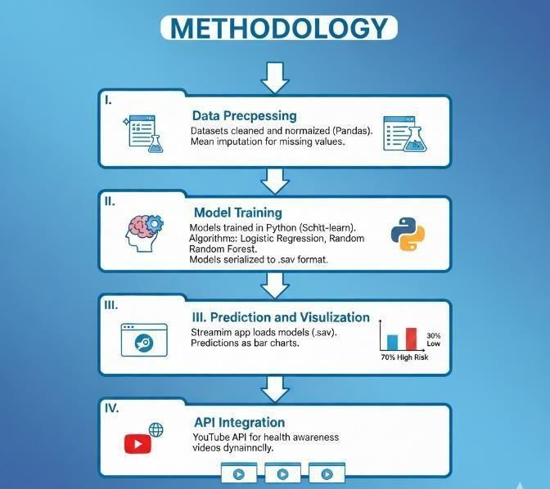

Fig 4.1 Overview of early Disease Detection System
In Fig 4.1 we are going to experiment on three diseases that are heart diabetes and Diabetic as these are correlated to each other. In the first phase, the datasets for different diseases are collected, cleaned, and normalized using Python libraries such as Pandas. Missing values in the dataset are handled using mean imputation to ensure uniformity and accuracy. This step ensures that the data fed into the machine learning models is consistent, reliable, and ready for analysis. Proper preprocessing significantly improves the performance and stability of the predictive models. After preprocessing, the cleaned datasets are used to train machine learning models using the Scikit-Learn library. Algorithms such as Logistic Regression, Random Forest, and K-Nearest Neighbors (KNN) are applied based on the nature of the disease dataset. Each model is evaluated for accuracy, and the best-performing ones are selected. These models are then serialized and saved in .sav format so they can be loaded later without retraining. This phase builds the core intelligence of the system. To enhance user experience and support awareness, the system integrates the YouTube API. This API dynamically fetches and displays health-related educational videos, providing users with additional knowledge about disease prevention

Chapter 5

SYSTEM DESIGN
Design is essentially the bridge between requirement specification and the final solution for satisfying the requirements. System design serves as a detailed blueprint or structured plan that outlines how the system components will work together to achieve the desired functionality. It defines the architecture, modules, data flow, interfaces, and interactions within the system to ensure smooth implementation. A well-structured design helps in identifying potential issues early, reducing development risks and costly revisions later. It also ensures that the system remains scalable, maintainable, and adaptable to future enhancements. Ultimately, effective system design provides a clear roadmap for developers, ensuring the successful execution and deployment of the software. The equipment's needed to implement the new system is chosen. At this stage, it is kept in mind that the proposed system is aimed at removing the shortcomings of the old system. The proposed system should be designed in such a way that it overcomes the limitations in the existing system.

Architectural Design
In this phase, a deeper examination of the system’s conceptual layout is carried out, focusing specifically on the structure of data and the organization of databases. The goal is to understand how information will be stored, accessed, and managed within the system. Careful planning of the data flow, entities, relationships, and storage mechanisms ensures that the system will operate efficiently and remain scalable for future enhancements. Along with defining the data structures, this phase also identifies the key inputs and outputs essential for system functionality. It clearly outlines which components of the proposed system will be automated, ensuring that all automated processes are logically designed and aligned with the overall system objectives. This detailed design work forms the foundation for accurate implementation and seamless user interactions.

Additionally, this stage ensures that every functional element of the system is mapped precisely to its corresponding operational requirement. By outlining workflows, processing rules, and system interactions, developers gain a clear blueprint for implementation. This reduces ambiguity during development and helps maintain consistency across modules. Ultimately, the detailed design created in this phase becomes a crucial reference that guides both development and future system modifications. It also enables easier debugging and optimization since each component's behavior is clearly documented.

Detailed Design

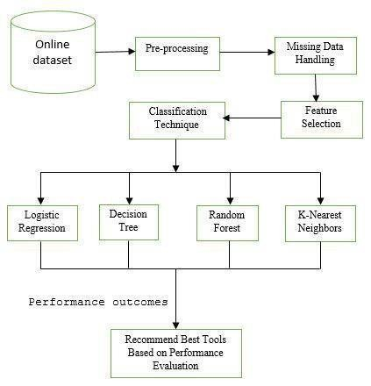
The Fig 5.1 illustrates the complete workflow of the classification process, starting from dataset acquisition and preprocessing to model evaluation.
Fig 5.1 Detailed Design of Early Disease Detection System

Output Design
A quality output is one, which meets the requirements of the end user and presents the information clearly. In any system results of processing are communicated to the users and to other system through outputs. In output design it is determined how the information is to be displaced for immediate need and also the hard copy output. It is the most important and direct source information to the user. Efficient and intelligent output design improves the system’s relationship to help user decision-making. Designing computer output should proceed in an organized, well thought out manner; the right output must be developed while ensuring that each output element is designed so that people will find the system can use easily and 39 effectively. When analysis design computer output, they should Identify the specific output that is needed to meet the requirements. Select methods for presenting information. Create document, report, or other formats that contain information produced by the system. The output form of an information system should accomplish one or more of the following objectives.

Input Design
The input design is the link between the information system and the user. It comprises the developing specification and procedures for data preparation and those steps are necessary to put transaction data in to a usable form for processing can be achieved by inspecting the computer to read data from a written or printed document or it can occur by having people keying the data directly into the system. The design of input focuses on controlling the amount of input required, controlling the errors, avoiding delay, avoiding extra steps and keeping the process simple. The input is designed in such a way so that it provides security and ease of use with retaining the privacy. Input Design considered the following things: What data should be given as input? How the data should be arranged or coded? The dialog to guide the operating personnel in providing input. Methods for preparing input validations and steps to follow when error occur.

Class Diagram
Class diagrams are widely used to describe the types of objects in a system and their relationships. Class diagrams model class structure and contents using design elements such as classes, packages and objects. Class diagrams describe three different perspectives when designing a system, conceptual, specification, and implementation. These perspectives become evident as the diagram is created and help solidify the design. Class diagrams are arguably the most used UML diagram type. It is the main building block of any object-oriented solution. It shows the classes in a system, attributes and operations of each class and the relationship between each class. In most modeling tools a class has three parts, name at the top, attributes in the middle and operations or methods at the bottom. In large systems with many classes related classes are grouped together to create class diagrams. Different relationships between diagrams are show by different types of Arrows and Fig 5.2 is an image of a class diagram.
Class diagrams play a crucial role in simplifying complex systems by visually organizing and categorizing the various components involved. They not only help developers understand the system architecture but also assist stakeholders in visualizing how different parts of the system interact. By providing a clear overview of class responsibilities and relationships, class diagrams support better planning, collaboration, and communication among project members. They also act as a reference throughout the development lifecycle, ensuring consistency during coding, testing, and maintenance phases. Ultimately, class diagrams contribute to creating robust, well-structured, and scalable object-oriented systems. They help identify potential design flaws early in the development process, reducing costly revisions later. Additionally, class diagrams enable easier scalability by offering a well-defined blueprint that guides future system enhancements.


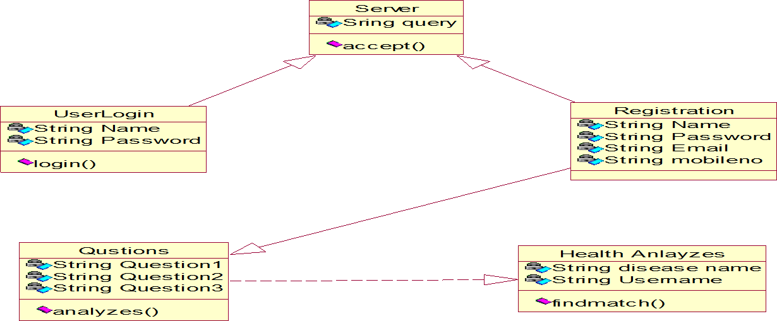
Fig 5.2 Class Diagram

Sequence Diagram
Sequence diagrams in UML shows how object interact with each other and the order those interactions occur. It’s important to note that they show the interactions for a particular scenario. The processes are represented vertically and interactions are show as arrows. This article explains the purpose and the basics of Sequence diagrams. A sequence diagram for a early disease prediction system illustrates the flow of interactions and data processing steps involved in predicting diseases based on user-provided information. At the outset, the user interacts with the system by inputting medical data such as symptoms, medical history, and potentially genetic information. This input is received by a controller or interface module, which acts as the entry point into the system. The input data then undergoes a series of processing steps, starting with data preprocessing where tasks like cleaning, normalization, and feature extraction are performed to prepare the data for analysis. Subsequently, the extracted features are used to select an appropriate prediction model, which could involve machine learning algorithms trained on historical datasets. Once the relevant model is selected, the system proceeds to generate a disease prediction and risk score, which is then sent back to the controller for display to the user. The Fig 5.3 sequence diagram clearly maps these interactions step-by-step, ensuring that each component’s role is well understood. It also helps developers identify potential delays, dependencies, or inefficiencies in the workflow.

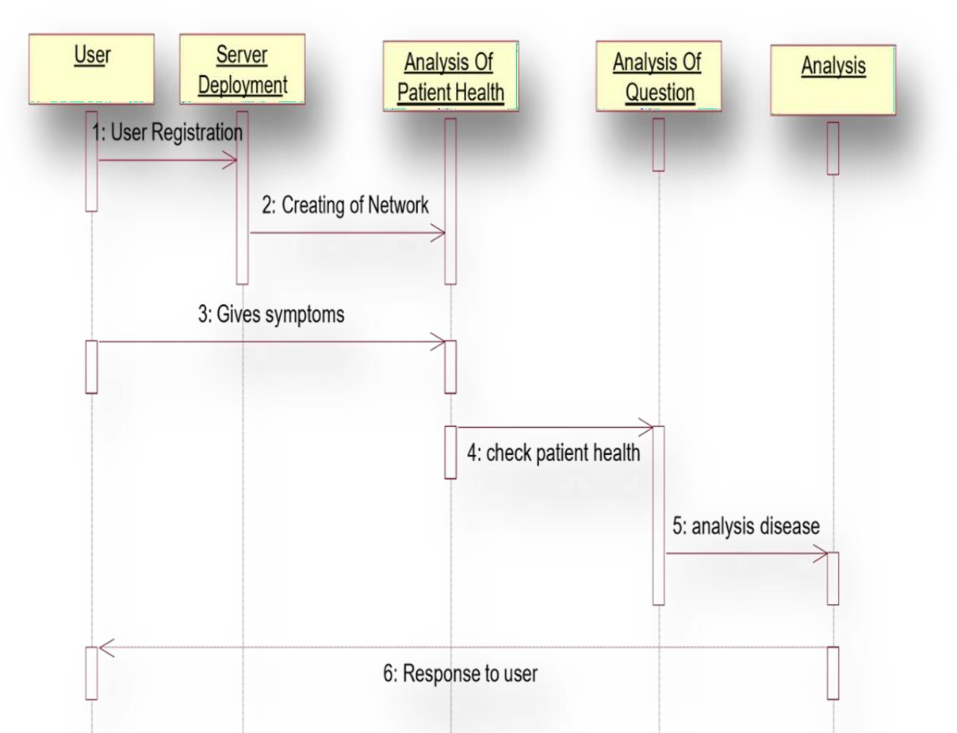
Fig 5.3 Sequence Diagram

Activity Diagram
The Fig 5.4 shows Activity diagram describe the workflow behavior of a system. Activity diagrams are similar to state diagrams because activities are the state of doing something. The diagrams describe the state of activities by showing the sequence of activities performed. An activity diagram for a early disease detection system depicts the workflow and activities involved in the process of predicting diseases based on input data. This diagram typically starts with an initial node representing the beginning of the prediction process. The first activity in the diagram is often data collection, where the system gathers input from users, which may include medical history, symptoms, and other relevant information.
The collected data then flows into activities for data preprocessing, such as cleaning, filtering, and normalizing the data to prepare it for analysis. After model training, the prediction activity takes place, where the trained model processes new input data to predict early diseases. The predicted outcomes are typically probabilities or class labels associated with disease. Finally, the diagram concludes with an activity for result presentation, where the predicted disease outcomes are formatted and displayed back to the user through the system's interface. By visualizing these workflow steps, the diagram helps developers and stakeholders understand the overall functionality and optimize the system for accuracy, efficiency, and user experience.

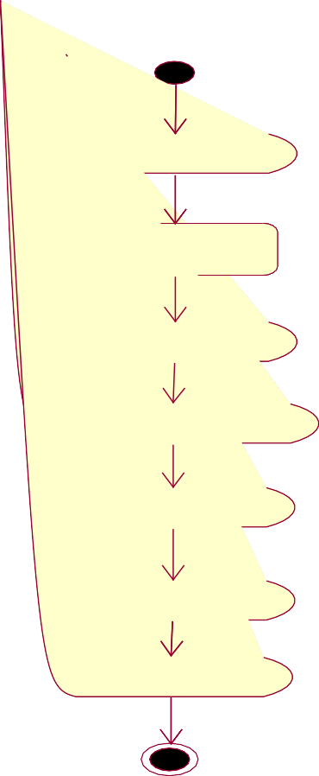

Login

Disease

Server

Analysis of Patient
Health Condition

Formulation Questions

Evidence Gathering

Resultant
Fig 5.4 Activity Diagram

Data Flow
In Fig 5.5 The DFD is also called as bubble chart. It is a simple graphical formalism that can be used to represent a system in terms of input data to the system, various processing carried out on this data, and the output data is generated by this system. The data flow diagram (DFD) is one of the most important modeling tools. It is used to model the system components. These components are the system process, the data used by the process, an external entity that interacts with the system and the information flows in the system.
DFD shows how the information moves through the system and how it is modified by a series of transformations. It is a graphical technique that depicts information flow and the transformations that are applied as data moves from input to outputted help simplify complex systems by breaking them down into smaller, manageable components, making it easier for developers and stakeholders to understand the overall data. They also provide a clear visual representation hat aids in identifying redundancies.

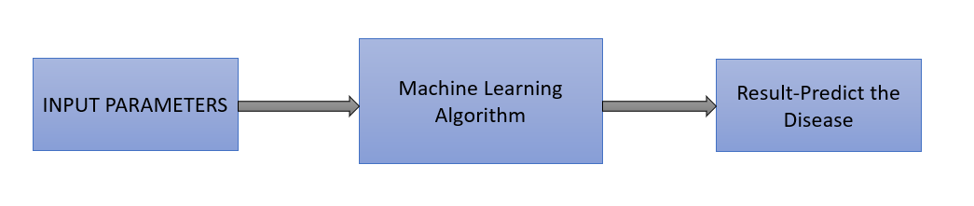

Figure 5.5 Data Flow Diagram Level 0 for Disease Detection


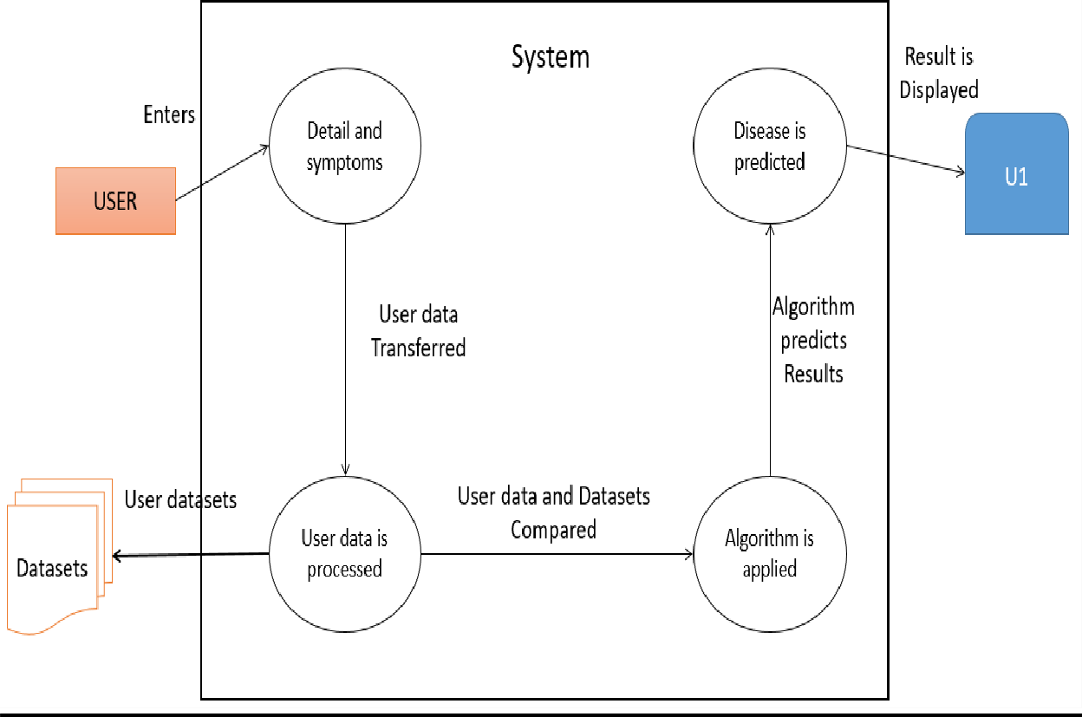
Fig 5.6 Data Flow Diagram Level 1 for Disease Detection

Fig 5.6 represents the Level 1 Data Flow Diagram for the Disease Detection system, illustrating the detailed flow of data between the user, processing components, and data storage units. At this level, the diagram breaks down the main process into sub-processes such as data input, data preprocessing, model analysis, and result generation. User-provided health parameters and symptoms are first captured and then passed to the preprocessing unit for cleaning and feature extraction. Finally, the processed results are sent back to the user through the system interface, completing the cycle of data movement and transformation. Additionally, this level of the DFD highlights the interaction between internal components, ensuring smooth communication between modules. It helps identify potential data bottlenecks and ensures that each process receives the necessary information at the right time.

Chapter 6

IMPLEMENTATION

In our Health care Project, we amalgamated both structured and unstructured data to gauge disease risk. To address missing data in medical records sourced from online platforms, we employed a latent factor model. Beyond risk prediction, our system also provides smart appointment booking by connecting patients with appropriate specialists based on their predicted health conditions. Additionally, it offers personalized healthcare video suggestions, recommending educational videos, preventive care tutorials, and doctor-verified health content tailored to each user's risk profile and medical history.
Data Collection: For our data collection process, we sourced information from the internet to identify specific diseases. We made sure to collect real symptoms of the diseases, without inserting any dummy values. These symptoms were gathered from various reputable health-related websites. This meticulous approach ensured that our dataset accurately reflected the symptoms associated with each disease, contributing to the reliability and authenticity of our research findings.
Data Preprocessing: Prior to inputting the data into the prediction model, we execute several data cleaning and preprocessing procedures. These steps ensure the data's quality and enhance the model's performance:
Checking for null values: Utilizing the forward fill method for filling any missing values. Standardizing the data by adjusting it to have a mean of zero and a standard deviation of one. This step aids in comparing variables with different scales and distributions. Dividing the dataset into training and testing sets. This division allows us to train the model on one portion of the data and validate its performance on another, ensuring generalizability and assessing the model's ability to make accurate predictions on unseen data.
Building Model: In the process of building our model, we employ various data mining methods, with machine learning being a prominent approach. Within machine learning, techniques like random forest and Support Vector Machine (SVM) are utilized. Machine learning encompasses strategies such as grouping, clustering, and summarization, among others. Given that our project involves classification, which is a crucial aspect of data mining, we focus on categorical data classification.
These algorithms enable the system to learn patterns from historical medical datasets and differentiate between healthy and disease-prone cases with high accuracy. During the model development phase, feature selection and parameter tuning are performed to enhance prediction.

Prediction is done by using Random Forest Algorithm and Support Vector Machine (SVM).

- Diabetes Diseases - Random Forest Algorithm
- Heart Diseases - Random Forest Algorithm
- Parkinson’s Diseases – Support Vector Machine (SVM).

Algorithm

Random Forest Algorithm

Random Forest operates through a two-phase process. In the first phase, it constructs a random forest by combining early decision trees.
This process involves several steps:
Step-1: A random subset of the training data is selected.
Step-2: A decision tree is built using the selected subset of data points.
Step-3: The number of decision trees to be included in the random forest, denoted by N
Step-4: Steps 1 and 2 are repeated N times to create N decision trees.
Step-5: When presented with new data points, each decision tree makes prediction.
Step-6: The final prediction for the new data point is determined by aggregating prediction.

Support Vector Machine (SVM)

Regarding the Support Vector Machine (SVM) algorithm, its primary form is the SVM classifier. The SVM classifier establishes a hyperplane in an N-dimensional space to separate data points of different classes.
Here are the steps involved:
Step-1: The SVM algorithm predicts classes, designating one class as 1 and the other class-1
Step-2: Like other machine learning algorithms, SVM transforms the problem.
Step-3: This loss function, or cost function, evaluates the discrepancy between predictions.
Step-4: Optimization involves adjusting weights through the calculation of gradients
Step-5: The gradients are updated using the regularization parameter.

The Random Forest algorithm is particularly effective in healthcare prediction tasks due to its robustness against noise, overfitting, and missing values. By constructing multiple independent decision trees and aggregating their outputs, the model reduces bias and variance, leading to more stable and reliable predictions. Each tree learns different feature relationships from varied subsets of the dataset, which enhances the diversity of learned patterns and improves classification accuracy.

Support Vector Machine (SVM) is a powerful supervised machine learning algorithm widely used for classification and regression tasks, especially when dealing with high-dimensional data. SVM works by finding an optimal hyperplane that best separates data points of different classes with the maximum margin, ensuring accurate and robust classification. In cases where data is not linearly separable, SVM uses kernel functions such as polynomial, radial basis function (RBF), or sigmoid to transform the input space into a higher dimension, allowing for effective separation. Its ability to handle complex relationships, reduce overfitting through regularization, and perform well even with limited training samples makes SVM ideal for medical applications like disease detection. Overall, SVM provides high accuracy, strong generalization capability, and reliable performance across diverse datasets.
SVM is particularly advantageous in scenarios where the dataset contains noise or overlapping classes, as it focuses only on the most critical data points known as support vectors. These support vectors determine the decision boundary, making the model both efficient and less sensitive to irrelevant features. Moreover, SVM offers flexibility through its kernel trick, enabling it to adapt to linear as well as highly nonlinear patterns within medical data. Its mathematical foundation ensures strong theoretical guarantees, helping achieve consistent and reliable predictions. Due to these strengths, SVM remains a preferred algorithm in healthcare analytics, bioinformatics, and other domains requiring precise and interpretable classification results.
Furthermore, SVM is computationally efficient, making it suitable for medium-sized datasets commonly used in medical prediction systems. Its ability to balance complexity and accuracy ensures stable performance across different disease categories. As a result, SVM continues to be a dependable choice for building robust and trustworthy diagnostic models. Its strong generalization capability helps the model perform well on unseen medical data. Additionally, SVM’s flexibility in choosing kernel functions allows it to capture both linear and non-linear patterns in medical datasets, enhancing prediction accuracy.
In addition to its predictive strength, SVM supports effective feature-based decision making, which is highly valuable in healthcare analytics where clinical attributes must be interpreted carefully. By assigning greater emphasis to relevant features during margin optimization, SVM helps identify which medical parameters contribute most to disease risk, supporting early diagnosis and informed clinical assessment. This interpretability makes the algorithm suitable for research-driven medical systems, where understanding model behavior is as important as achieving high accuracy. Overall, the integration of SVM in healthcare prediction models enhances reliability, supports evidence-based analysis, and contributes to improved patient monitoring.

Chapter 7

MODULE SPLIT UP

Identify and gather data from diverse sources such as hospitals, clinics, research institutions, and public health databases. Collect data covering various diseases of interest, including demographic information, clinical measurements, medical history, lifestyle factors, and genetic information if available. Ensure the dataset is representative, balanced, and includes sufficient samples for each disease category.

Dataset Collection
Identifying Data Sources: Look for publicly available datasets from sources like UCI Machine Learning Repository, Kaggle, government health agencies, or collaborate with healthcare institutions for access to clinical data.

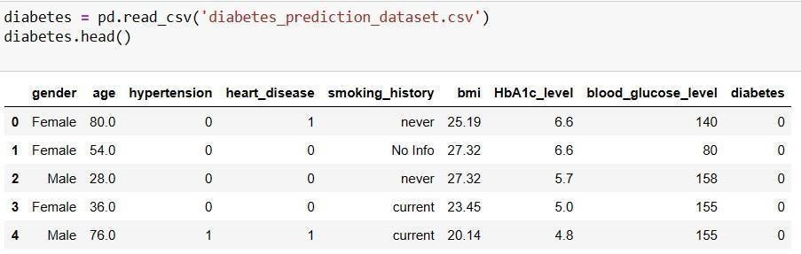
Data Acquisition: Acquire data in various formats such as CSV, Excel, or relational databases. Ensure compliance with data protection regulations and obtain necessary permissions if working with sensitive health data.

Fig 7.1 Dataset Collection for Diabetes Disease Detection

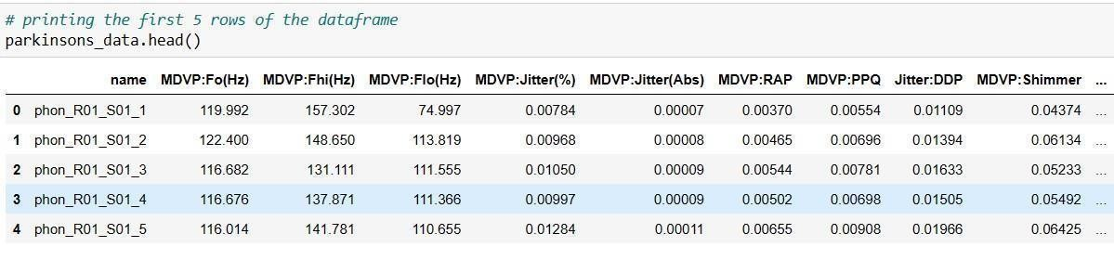
In Fig 7.1 Dataset is collected for Diabetes disease which has 8 attributes.
have trained 80% of the data and 20%of the data is tested.

Fig 7.2 Dataset Collection for Parkinsons Disease Detection

In the Fig 7.2 Dataset is collected for Parkinson’s disease which has 20 attributes and we have trained 80% of the data and 20%of the data is tested.

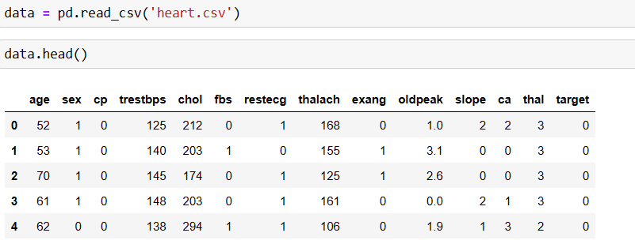

Fig 7.3 Dataset Collection for Heart Disease Detection
In the Fig 7.3 Dataset is collected for heart disease which has 13 attributes and we have trained 80% of the data and 20%of the data is tested

Data Analysis and Preprocessing
Perform Exploratory Data Analysis (EDA) to understand the distribution of features, identify patterns, and detect anomalies. Handle missing values by imputation techniques such as mean, median, or mode imputation, or using advanced methods like KNN imputation. Address outliers through methods such as trimming, winterization, or removing them if they are erroneous. Encode categorical variables using techniques like one-hot encoding or label encoding. Normalize or standardize numerical features to ensure uniform scale across different features.
Exploratory Data Analysis (EDA): Visualize the data using histograms, box plots, scatter plots, etc., to understand distributions, relationships, and identify outliers or missing values. Use techniques like mean, median, or mode imputation, or advanced methods such as KNN imputation or interpolation to fill missing values. Outlier Detection and Treatment: Identify outliers using statistical methods or visualization techniques and decide whether to remove, transform, or impute them based on domain knowledge.
Feature Scaling and Normalization: Scale numerical features to a similar range to prevent dominance of certain features during model training.
Encoding Categorical Variables: Convert categorical variables into numerical representations using techniques like one-hot encoding or label encoding.
Feature Selection: Select relevant features using statistical tests, domain knowledge, or feature importance techniques to reduce dimensionality and improve model performance. Handling Missing Values: Detect and address missing data through imputation or removal to ensure model accuracy and consistency. Data Normalization/Scaling: Apply scaling techniques such as Min-Max normalization or Standardization to ensure all features contribute equally during model training.

Feature Engineering
Create new features from existing ones that might improve predictive performance. Extract relevant information from text data using techniques like TF-IDF or word embeddings. Transform features using mathematical functions or domain-specific knowledge to make them more suitable for modelling. Select the most informative features using techniques like feature importance ranking or dimensionality reduction methods such as PCA (Principal Component Analysis).
Creating New Features: Engineer new features from existing ones that capture additional information relevant to disease prediction. For example, derive BMI from height and weight, or calculate ratios and proportions of clinical measurements.
Text Data Processing: If dealing with text data (e.g., medical notes or reports), preprocess it by tokenization, stemming, lemmatization, and remove stop words to extract meaningful features using techniques like TF-IDF or word embeddings.
Temporal Features: Extract temporal patterns from time-series data such as trends, seasonality, and periodicity to capture disease progression over time.
Domain-Specific Features: Incorporate domain-specific knowledge or expert-derived features that are known to be predictive of certain diseases.

Splitting the Dataset
Divide the pre-processed dataset into training, validation, and testing sets. Typically, allocate around 80% of the data to training and the remaining 20% to testing. Ensure that the distribution of classes is similar across the training, validation, and testing sets to avoid bias.
Train-Validation-Test Split: Split the dataset into three subsets: training set and test set, typically in an 80-20 ratio respectively.
Stratified Sampling: Ensure that each subset maintains the same class distribution to prevent bias in model evaluation.
Cross-Validation: Optionally, use techniques like k-fold cross-validation on the training set to further validate model performance and robustness.

Training Model
Choose appropriate machine learning algorithms for multiple disease prediction, considering factors like interpretability, scalability, and performance. Train the selected models using the training data, tuning hyperparameters using techniques like grid search or random search. Experiment with ensemble methods such as random forests or gradient boosting to improve predictive accuracy. Implement techniques to handle imbalanced classes if present, such as oversampling, under sampling, or using class weights. Evaluate model performance using metrics like accuracy, precision, recall, F1-score, and AUC-ROC to ensure reliable predictions.


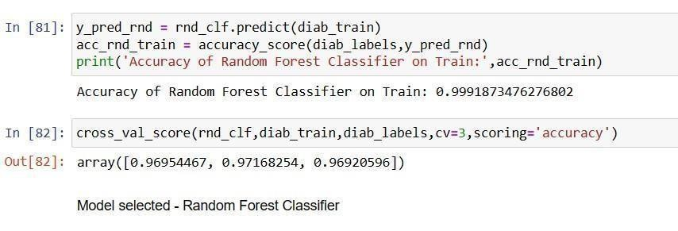
Choose appropriate machine learning algorithms such as logistic regression, decision trees, random forests, support vector machines, or deep learning models based on the nature of the problem and data characteristics.

Fig 7.4 Model-Selection for diabetes Disease Detection

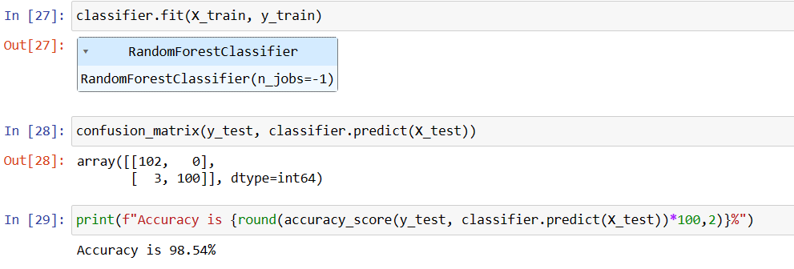
In the Fig 7.4 we have implemented using Random Forest Algorithm for Diabetes Disease Prediction System with the best accuracy of 99%

Fig 7.5 Model-Selected for Heart Disease Detection
In the Fig 7.5 we have implemented using Random Forest Algorithm for Heart Disease Prediction with the best accuracy of 98.5%.
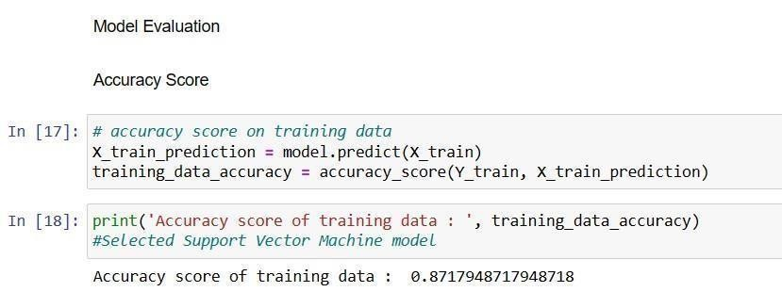

Fig 7.6 Model-Selected for Parkinsons Disease Detection
In the Fig 7.6 we have implemented using Support Vector Machine for Parkinson’s
Disease Prediction with the accuracy of 87.2%.

Evaluating and Testing
Evaluate the trained models using the validation set to assess their performance metrics like accuracy, precision, recall, F1-score, and area under the ROC curve (AUC). Fine-tune the models based on validation performance to improve generalization. Finally, assess the models' performance on the testing set to ensure unbiased evaluation and estimate real-world performance. Model Evaluation Metrics: Evaluate model performance using metrics like accuracy, precision, recall, F1-score, ROC-AUC, and confusion matrix on the validation set.
Fine-Tuning: Based on validation performance, fine-tune models by adjusting hyperparameters or feature selection strategies to improve generalization.
Final Testing: Evaluate the best-performing model(s) on the test set to obtain an unbiased estimate of model performance and assess real-world generalization ability.
Precision and Recall: Score for Diabetes Disease Prediction system Precision-0.9333333 Recall-0. 6777.
Furthermore, the model's performance metrics provide insights into strengths and weaknesses across different disease categories. For instance, high precision indicates that when the system predicts a disease, it is usually correct, whereas recall shows how well the system can identify all actual disease cases. In the example of the diabetes disease prediction system, a precision of 0.93 suggests strong correctness in positive predictions, while a recall of 0.67 indicates moderate sensitivity. These metrics guide further optimization to achieve a balanced performance. Continuous testing, feedback incorporation, and periodic model retraining help enhance the model’s robustness and ensure long-term reliability in real-world healthcare environments.
Evaluating and testing the models is a crucial step to ensure that the disease prediction system is both reliable and effective when applied to real-world scenarios. During this phase, various techniques such as cross-validation, hyperparameter tuning, and error analysis are performed to refine the model’s behavior. Confusion matrices help identify misclassification patterns, allowing developers to understand whether the model is struggling with false positives, false negatives, or both. These metrics guide further optimization to achieve a balanced performance. Continuous testing, feedback incorporation, and periodic model retraining help enhance the model’s robustness and ensure long-term reliability in real-world healthcare environment. Performance metrics such as accuracy, precision, recall, and F1-score are thoroughly examined to assess how well the model generalizes to unseen data. Stress testing is conducted to evaluate how the system performs under varying data loads and edge-case scenarios, ensuring stability and responsiveness.

Chapter 8

TESTING

The purpose of testing is to discover errors. Testing is the process of trying to discover every conceivable fault or weakness in a work product. It provides a way to check the functionality of components, subassemblies, assemblies and/or a finished product It is the process of exercising software with the intent of ensuring that the software system meets its requirements and user expectations and does not fail in an unacceptable manner. There are various types of tests. Each test type addresses a specific testing requirement.

Unit testing
Unit testing is the first level of dynamic testing and focuses on verifying the smallest testable parts of the software typically individual functions, methods, or classes. Initialization testing ensures that all variables, objects, and data structures are correctly set up before use. It is primarily the responsibility of developers, although test engineers may also participate. Unit tests help identify issues early in development, reducing cost and complexity in later stages. These tests are usually automated and executed repeatedly after every code change to ensure stability. Unit testing is considered complete when expected test results are met, or when deviations can be reasonably explained and accepted.

Integration testing
Integration testing verifies that multiple modules or components work correctly when combined. Even if modules function individually, issues may arise when they interact, so this testing focuses on checking data flow, interface compatibility, and communication between units. Different strategies, such as top-down, bottom-up, or hybrid approaches, may be used depending on the system architecture. The primary goal is to ensure that the interaction between two or more components produces results that fulfill the defined functional requirements and that no interface- related defects remain.

System testing
System testing evaluates the complete and integrated software system in a controlled environment to ensure it meets both functional and non-functional requirements. It is a black-box testing activity usually conducted by the Test Team rather than developers. This phase includes validating system behavior in real-world scenarios and checking performance, security, usability, and reliability. The testing environment is configured to closely resemble the production environment, ensuring that the end-to-end workflow operates as expected before deployment.

Functional testing
Functional testing ensures that the system behaves according to the defined functional specifications by examining user interactions, inputs, outputs, and expected behaviors. It involves testing all outgoing and internal page links, verifying navigation paths, checking default values of input fields, and validating how the system responds to both valid and invalid inputs. This testing confirms that each feature performs as intended, that user actions produce correct results, and that the overall functionality of the application remains error-free.

Alpha testing
Alpha testing is conducted near the end of the development cycle and takes place at the developer’s site under a controlled environment. It is performed by internal staff or selected end users to identify issues that earlier testing phases may have missed, especially usability defects or workflow inconsistencies. This type of testing aims to simulate real user behavior and uncover critical bugs before the product is made available to external users. Alpha testing serves as a final quality check before beta release. Feedback from alpha testers helps developers refine features and fix defects before exposing the product to a larger audience.
It ensures the product is stable enough to proceed to the beta phase with minimal critical issues.

Beta testing
Beta testing is performed after alpha testing and involves real end users operating the software in their own environments. Conducted at one or more customer sites, it identifies issues that arise under real-world usage conditions that developers cannot fully replicate. Beta testing provides valuable feedback on usability, performance, compatibility, and reliability, helping ensure that the product meets customer expectations. This stage allows the development team to refine the software before the final public release. Insights from beta testers guide final adjustments, ensuring the software performs well across diverse hardware and usage scenarios. Successful beta testing increases confidence that the product is ready for market release with high user satisfaction.

Unit testing cases
Initialization testing is the first level of dynamic testing and is first the responsibility of developers. It verifies that all variables, objects, and data structures are correctly initialized. Unit testing cases are designed to validate individual software components by checking their behavior with normal, boundary, and erroneous inputs. Initialization testing ensures that all variables, objects, data structures, and system states are properly prepared before execution. Each test case includes specific input, expected output, and the actual observed result. Well-designed unit test cases help improve overall code quality, maintainability, and reduce the likelihood of errors affecting later.

Table 8.1 Sample Test Cases
Table 8.1 shows the sample test cases designed to validate the complete workflow of the proposed system. It outlines each testing phase along with the corresponding inputs, expected re
-sults, and remarks to ensure proper system functionality.

Id | Test Case Title | Test Input | Result | Remarks
TC_1 | Data Upload Dataset File Path | File uploaded | Successfully | Pass
TC _2 | Data Cleaning | Raw Dataset | Cleaned Data | Pass
TC _3 | Data Preparation for Training | Dataset and Split-Ratio | Train-set and Test- set created successfully | Pass
TC _4 | Model Construction and Training | Training Algorithm and Train-set | Model trained successfullyusing train-set | Pass
TC _5 | Model Validation | Trained Model and Test-set | Displaymodel validation parameters with its values | Pass
TC _6 | Display Result | Model Performance Statistics | Classification accuracy | Pass

The testing process covers the complete workflow of the system, starting from data upload (TC_1), data cleaning (TC_2), and data preparation for training (TC_3). It then verifies model construction and training (TC_4), followed by model validation using the test set (TC_5), and finally ensures results are displayed correctly with performance metrics (TC_6).

Chapter 9

RESULTS AND DISCUSSIONS

In the disease prediction system, distinct machine learning algorithms are tailored to specific diseases based on their performance. For instance, the Random Forest algorithm is utilized for diabetes prediction and heart disease prediction, and Support Vector Machine (SVM) algorithm for Parkinson’s diseases due to their superior accuracies in respective domains.

Table 9.1 Accuracy level for all three Diseases.

Model | Algorithm | Accuracy
Diabetes Diseases | Random Forest Algorithm | 99%
Heart Diseases | Random Forest Algorithm | 98.54%
Parkinson’s Diseases | Support Vector Machine | 87.17%
When a patient inputs parameters corresponding to a particular disease, the system evaluates whether the patient is likely to have that disease based on the provided information. Parameters are accompanied by prescribed value ranges, ensuring validity and relevance. Should the entered values fall outside the specified ranges, be invalid, or be left empty, the system prompts the user to correct them by displaying a warning sign. This mechanism helps ensure accurate and reliable predictions tailored to individual patient profiles and disease categories. and if the person is having disease the patient can add the timings to remind to take the pills (tablets).
In Table 9.1 we can see that the system diabetes disease prediction model used Random Forest Algorithm, heart disease uses the Random Forest Algorithm and Parkinsons Disease uses the Support Vector Machine (SVM) algorithm as these gave the best accuracy accordingly. There when the patient adds the parameter according to the disease it will show whether the patient has a disease or not according to the disease selected. The parameters will show the range of the values needed and if the value is not between the range or is not valid or is empty it will show the warning sign that add a correct value. Once after giving all the Parameter Properly then it Displays the Result with Food Recommendation for that particular Person.
Parameters are accompanied by prescribed value ranges, ensuring validity and relevance. Should the entered values fall outside the specified ranges, be invalid, or be left empty, the system prompts the user to correct them by displaying a warning sign. if the person is having disease the patient can add the timings to remind to take the pills (tablets). The system maintains a record of these reminders to help patients adhere to their prescribed medication schedule. It can generate notifications or alerts at the specified times to ensure timely intake of pills.

  - RESULTS
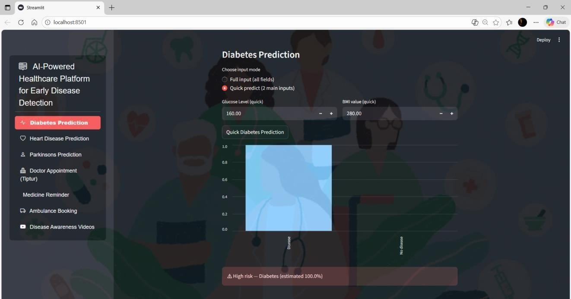
The Fig 9.1 shows the AI-powered platform predicting diabetes risk based on patient inputs, indicating a high-risk probability of 100%, visualized on a 0–1 scale for easy interpretation.

Fig 9.1 Diabetes Diseases Prediction

The Fig 9.2 heart disease risk based on patient inputs, indicating a low-risk probability of 45.5%, visualized on a 0–1 scale for clear interpretation.
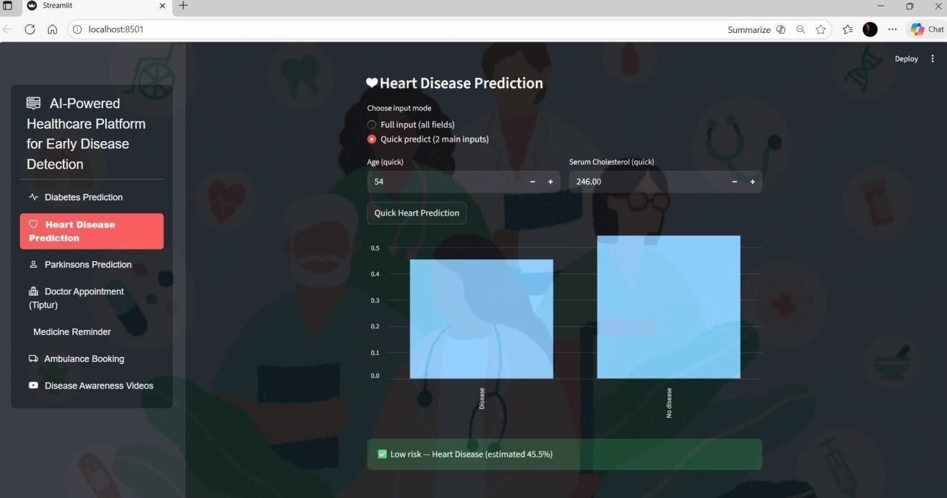

Fig 9.2 Heart Disease Prediction

The Fig 9.3 shows the AI-powered healthcare platform predicting heart disease risk based on patient inputs, indicating a low-risk probability of 45.5%, visualized on a 0–1 scale for clear interpretation.
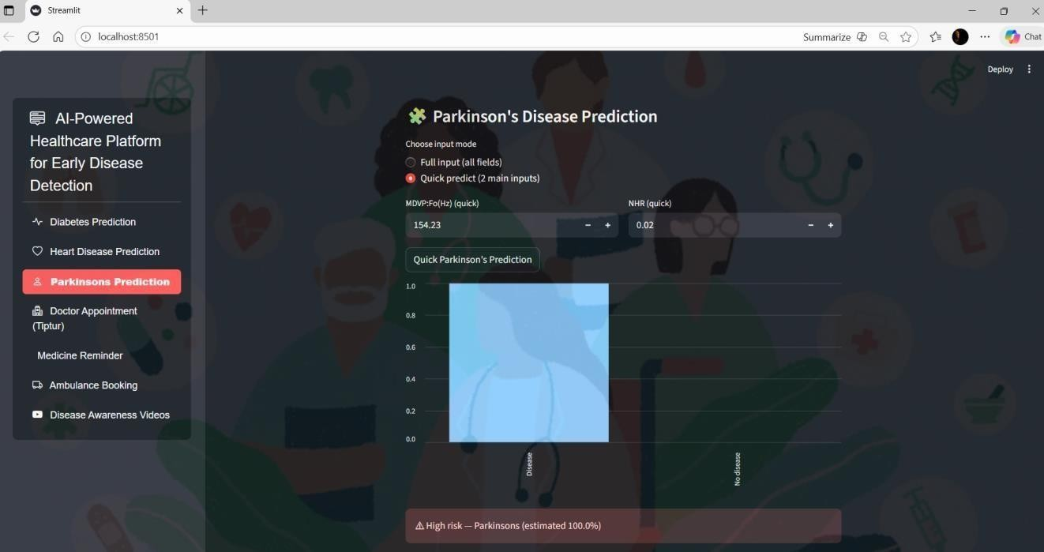

Fig 9.3 Parkinson’s Disease Prediction

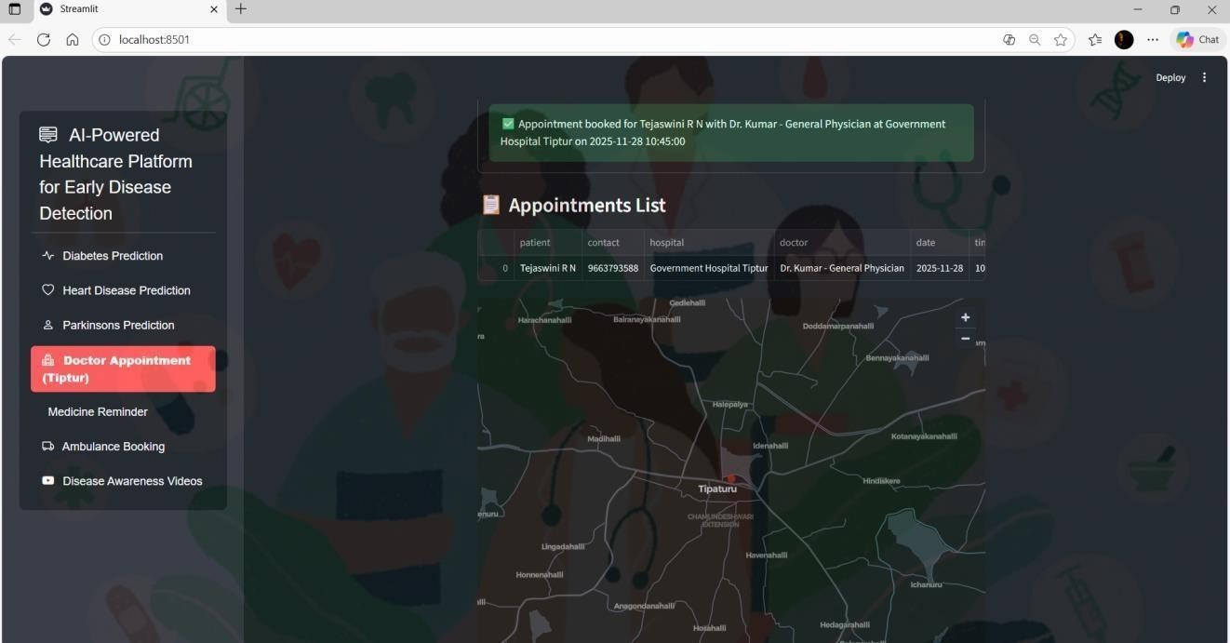
The Fig 9.4 shows the platform’s appointment scheduling module, where the user selects a hospital, doctor, date, and time, resulting in a confirmed booking and an updated appointments list and location map displayed on the interface.

Fig 9.4 Doctor Appointment Booking

The Fig 9.5 displays where users enter medication details, dosage, frequency, and schedule, resulting in an automated reminder being set and listed under active reminders.
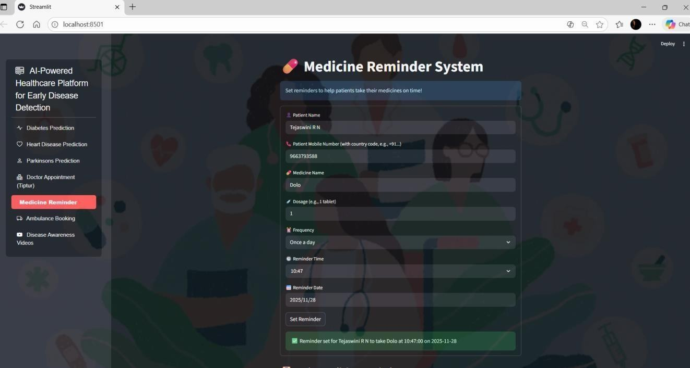

Fig 9.5 Medicine Reminder System

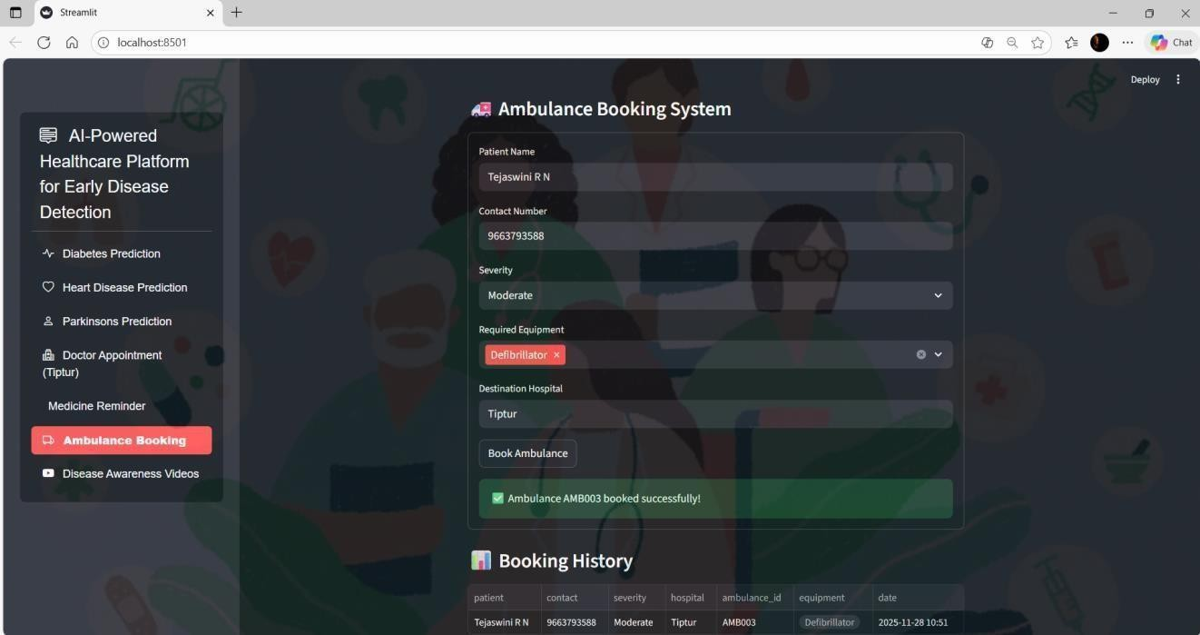
The Fig 9.6 shows the emergency ambulance booking module, where the user enters patient details, severity level and required equipment.

Fig 9.6: Doctor Appointment Booking (Location Map)

The Fig 9.7 and 9.8 shows the interface allows users to search YouTube for medically verified disease-awareness videos, helping them understand conditions like Parkinson’s disease through educational visual content.
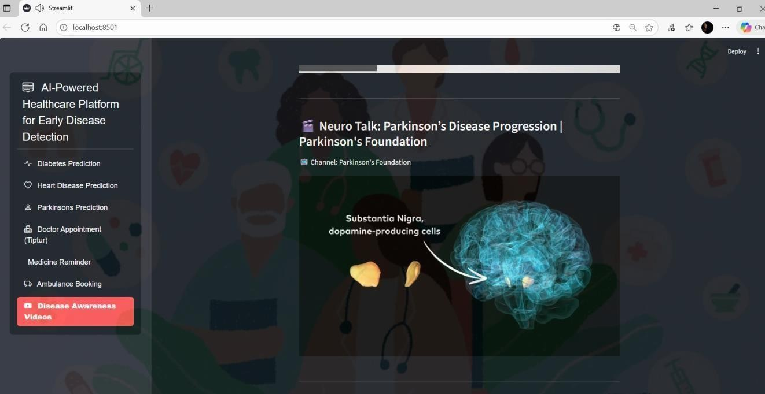
Fig 9.7 Disease Awareness videos
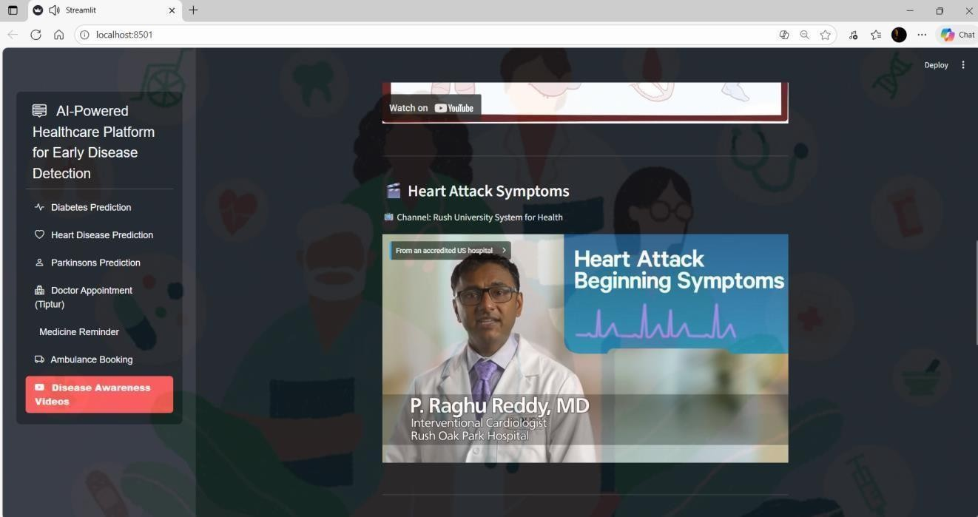
Fig 9.8 Heart Disease Awareness videos

Chapter 10

CONCLUSION AND FUTURE WORK

Our proposed AI-Powered Healthcare System for Early Disease Detection is designed to bridge the gap between doctors and patients by providing a reliable, intelligent, and user-centric platform. Unlike traditional systems that only automate predictions, our solution focuses on enhancing user trust by integrating doctor recommendations along with AI-driven results. This ensures that medical professionals remain an essential part of the decision-making process while patients receive timely and accurate guidance. The system leverages multiple machine learning models to detect a range of diseases at an early stage. By incorporating advanced algorithms such as Random Forest and XG Boost, the platform delivers robust and highly accurate predictions. These models enable early interventions, personalized treatment plans, and data-driven clinical decisions, ultimately improving patient outcomes. Additionally, AI-powered disease prediction supports healthcare providers by optimizing resource allocation and enabling precise risk assessment. On a broader scale, it contributes to population-level disease surveillance, aiding in the early detection of outbreaks and facilitating preventive healthcare strategies. In conclusion, this AI- based approach strengthens the healthcare ecosystem by combining machine learning, medical expertise, and patient-centric design. Through intelligent early disease detection, the system boosts diagnostic accuracy, enhances patient care, and supports a more efficient and proactive healthcare infrastructure.

Future Work
In the future, this AI-based healthcare system can be expanded to include more diseases, making it a more complete and powerful diagnostic tool. By adding additional disease prediction models, patients will receive a wider assessment of their health condition in a single platform, and doctors will be able to identify multiple health risks at the same time. Additionally, the system can be extended to include features such as real-time monitoring, integration with wearable health devices, personalized recommendations, automated medical reports, and telemedicine support. These enhancements will help patients monitor their health continuously and receive early warnings before serious complications occur. As the system evolves, incorporating advanced deep learning techniques and larger datasets will further improve prediction accuracy and reliability. The integration of cloud-based services can enable scalable storage and faster processing, allowing the platform to support a larger user base. Moreover, implementing multilingual support and voice. Future updates could also include wearable device integration for real-time monitoring.

REFERENCES

- Prashanth, Dr. Anu Rathee et. al., Evaluation and accurate diagnoses of pediatric diseases using artificial intelligence. Nat Med. 2019;25(3):433- 438.
- Indukuri Mohit, K. Santhosh Kumar, Avula Uday Kumar Reddy et. al., 2015;132(20):1920- 1930.
- Divya Mandem, B. Pranja et. al., "Effective heart disease prediction using hybrid machine learning techniques", IEEE Access, vol. 7, pp. 81542-81554, 2019.
- Mohammed Juned Shaikh, Soham Manjrekar, Danish Khan, Muzaffar Khan, Danish Jamadar et. al., "Classification of Chronic Kidney Disease using Feature Selection Techniques", IJCSE, vol. 6, no. 5, pp. 649- 653, 2018.
- Rudra A. Godse, Smita S. Gunjal, Karan A. Jagtap, Neha S. Mahamuni, Prof. Suchita Wankhade et. al. heart disease prediction using random forests. J Med Syst. 2019;43(10):329.
- Abhishek Pattar, Sameer Kurhade, Manoj Salunke et. al., Predicting the risk of type 2 diabetes mellitus using data mining techniques. J Diabetes Res. 2018; 2018:1686023.
- “Heart Disease Prediction using Logistic Regression Algorithm using Machine Learning”
Ankush Singh, Ashish Yadav, Saloni Shah, Renuka Nagpure et. al.
- Padmaja Pulicherla, Padala Raviteja, Peddi Akash, Veldhandi Sai Krishna et. al., “Heart Disease Prediction Using Machine Learning Algorithms”, 2020 IEEE, International Conference on Electrical and Electronics Engineering (ICE3)
- Ankush Singh1, Ashish Yadav2, Saloni Shah3, Prof. Renuka Nagpure4 (2022) Multiple Disease Prediction System.
- K. Gaurav, A. Kumar, P. Singh, A. Kumari, M. Kasar, and T. Suryawanshi, “Human disease prediction using machine learning techniques and real-life parameters,” Int. J. Eng. Trans. C: Aspects, vol. 36, no. 6, pp. 1092 - 1098, Jun. 2023.
- K. Reshma, P. Niharika, J. Haneesha, K. Raja Vardhan, and S. Swaroop, “Multi Disease Prediction System Using Machine Learning,” Int. Res. J. Modern. Eng. Tech. Sci., vol. 6, no. 2, p. 1740, Feb. 2024.
- J. Zheng, D. Lin, Z. Gao, S. Wang, M. He, and J. Fan, "Deep learning assisted efficient AdaBoost algorithm for breast cancer detection and early diagnosis," IEEE Access, vol. 8, pp. 96946 96954, 2020.
- T. Zhu, K. Li, P. Herrero, and P. Georgiou, "Deep learning for diabetes: a systematic review," IEEE Journal of Biomedical and Health Informatics, vol. 25, no. 7, pp. 2744-2757, 2020.

BIBLIOGRAPHY

NAME: Bindu H L USN:1KI22IS006 PhNo:7676242943  Address:Heruru,Dyager  -ahalli Post,Sira(T), Tumkur(D)  Email:binduhl239@gmail.com | 
NAME: Kushi P USN:1KI22IS022 PhNo:7795774088  Address: Vidyanagar, High Extension Road, Tiptur(T),Tumkur(D) Email:kuship726@gmail.com | 
NAME: Spoorthi K S USN:1KI22IS056 PhNo:9663417129  Address:Kadalamage,k.Kithinkere post,Arsikere (T), Hassan (D) Email:spoorthiks85@gmail.com | 
NAME:Tejaswini R N USN:1KI22IS058 PhNo: 9663793588  Address:Ramachandrapura,  At post Kasaba hobli,Tiptur(T), Tumkur(D)  Email: rntejaswini03@gmail.com | 

ANNEXURE
  - This annexure contains the certificate awarded by Kalpataru Institute of Technology, Tiptur, for the project titled “AI Powered Healthcare System.” The project was developed and presented by the team consisting of Tejaswini R N, Spoorthi K S, Kushi P, and Bindu H L Under the guidance of Divya C, Assistant Professor, Department of Information Science and Engineering. The team participated in the Project Exhibition held on 17th and 18th November 2025, where they showcased exceptional innovation, technical competence, teamwork, and creativity. In recognition of their outstanding performance, the project was honored with the Best Project Award and secured the 3rd Prize in Project Presentation. The certificate attached below is duly signed by Dr. Rajashekar K J, Professor & HOD, ISE, and Dr. Sateesh Kumar H. C., Principal, KIT, Tiptur.

  - This annexure includes the publication certificate awarded by the International Journal of Innovative Research in Technology (IJIRT) for the research paper titled “AI-Powered Healthcare Platform for Early Disease Detection.” The paper was authored by the project team comprising Tejaswini R N, Spoorthi K S, Kushi P, and Bindu H L and was published in Volume 12, Issue 6, November 2025 of IJIRT. The journal carries an ISSN of 2349–6002 and an Impact Factor of 8.017. The publication, registered under ID 187915, confirms that the project work underwent peer review and was accepted for publication in this international open-access journal. A scanned copy of the publication certificate issued by IJIRT is attached below.

PAPER PUBLICATION
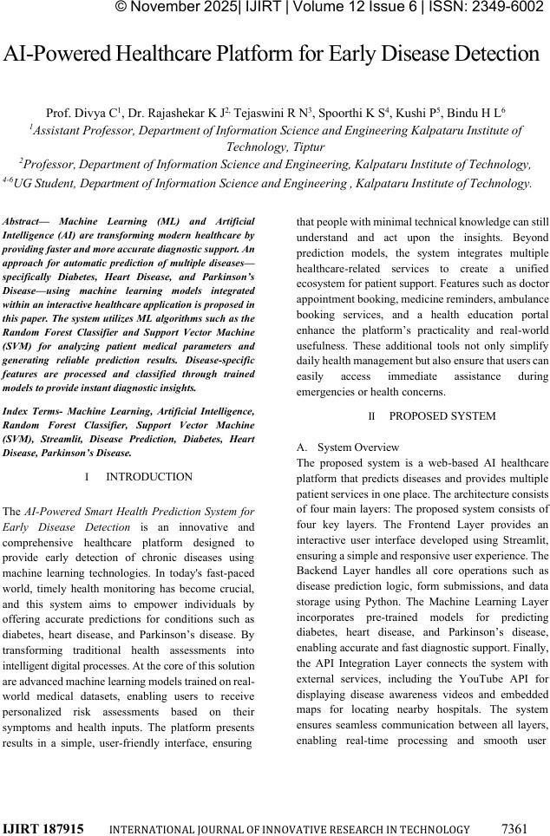

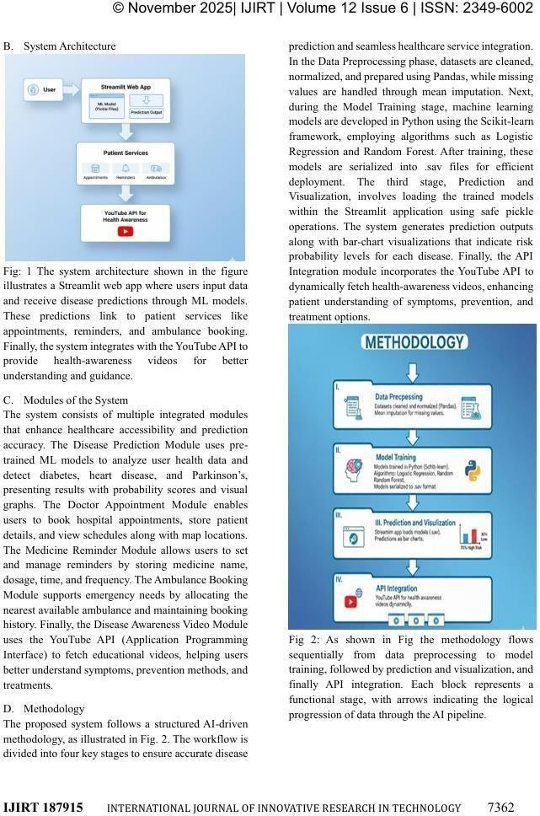

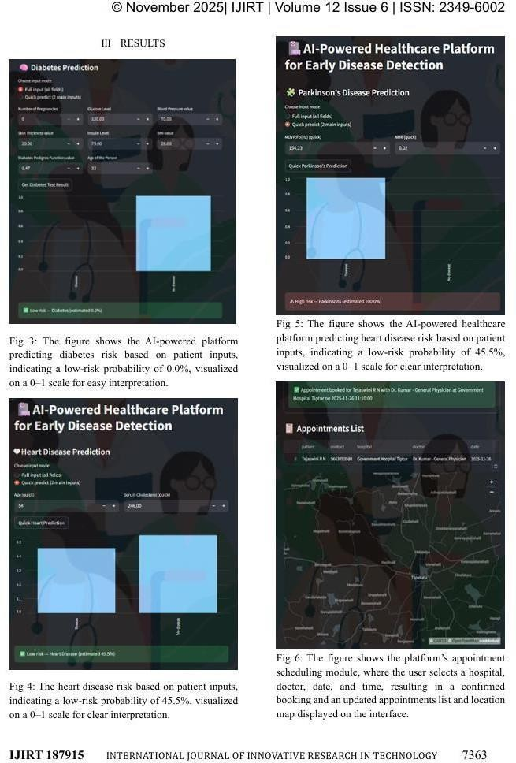

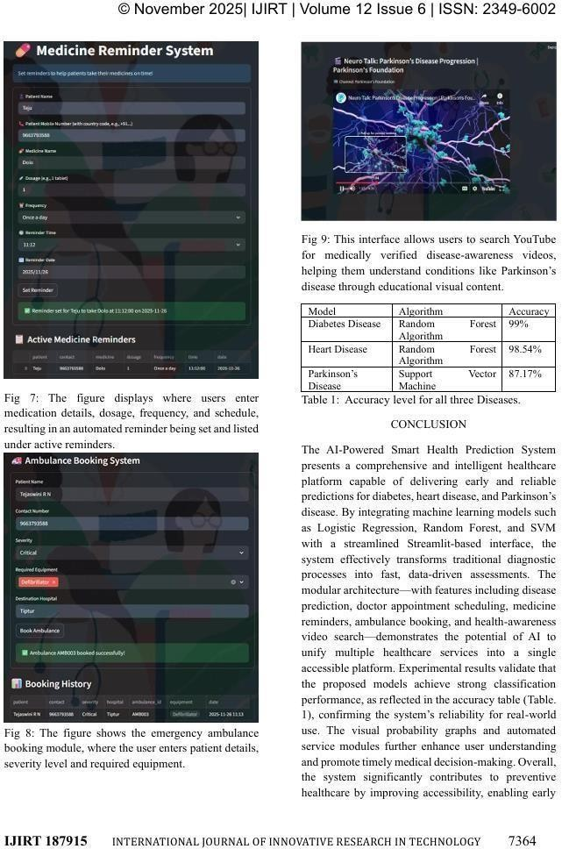

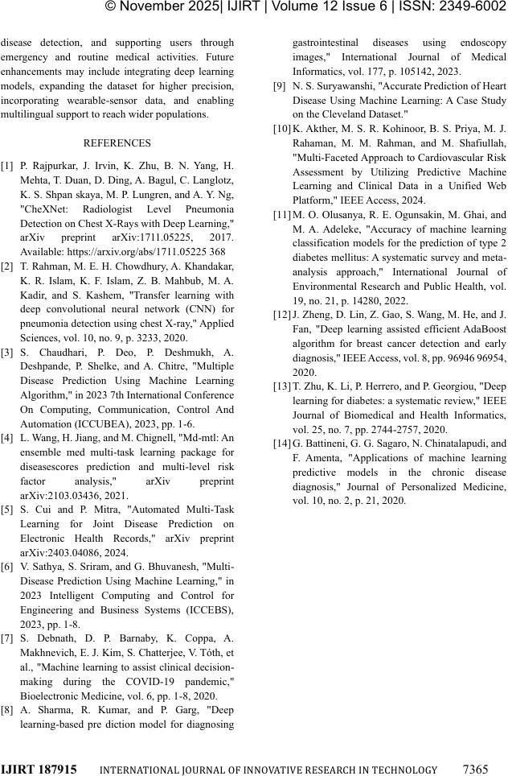

CERTIFICATE
- Publication Certificates








- Presentation Certificates







